Irrigation scheduling

Manage the water manage the plant

Irrigation scheduling is the most cost effective way of making more effective use of water.

It is more than just ensuring the plant has enough water, it is managing the growth characteristics of the plants by manipulating the availability of water.

Vegetative or reproductive growth (fruit production) is stimulated by applying surplus or deficit water to selective sections of the root zone.

It is essential to know exactly how much water the plant is using by accurately measuring the water use for the particular site. Traditional crop factors and evaporation may give a general indication but the actual water use varies significantly from site to site depending on the stage of growth of the plant, row spacing or crop density, the terrain etc.

Measuring actual plant water usage for a specific site is not difficult using a procedure called adaptive or self learning scheduling. This involves measuring evaporation, rainfall, water applied and soil moisture or irrigation depth and analyzing the information. This gives the true crop factor. This will vary as the plant grows and so must be measured throughout the season.

The irrigation depth or soil moisture is measured before and after irrigation and a revised crop factor recalculated. This crop factor is continuously adjusted as the plant grows.

This crop factor is measured for the particular site and is not a generic crop factor which may not be relevant to that site.

Once the true crop factor has been measured the effective water holding capacity of the soil can be found from monitoring the plant.

The techniques for measuring true crop factors and the water holding capacity of the soil are described later. First we will look at the types of irrigation schedules we can use, once we know the true crop factor.

Deep cycle irrigation

Classic irrigation scheduling uses the single or deep cycle principle. The water holding capacity of the soil is estimated from the field capacity of the soil and a refill point, some value above the wilt point. The soil is allowed to dry down to a refill point, and sufficient water added to refill the profile.

Single cycle does not give optimum growth and is only recommended for shallow rooted plants such as vegetables.

Dual cycle irrigation

Dual cycle irrigation gives higher production, is more water efficient and is recommended for deeper rooted plants.

Dual cycle means applying a large irrigation to wet the entire profile then a series of smaller irrigation to maintain the upper soil moist.

Soils will dry down progressively from the surface; dual cycle irrigation maintains both deep and shallow moisture levels without saturation.

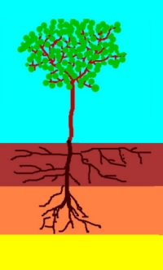 | Many plants have two root systems. In the nutrient rich upper layer they will have fine feeder roots. If this upper layer is adequately moist the plant can extract all the food and water it needs.  If the upper layer dries out it will use it survival roots to extract moisture. Many nutrients like phosphorus and calcium are not mobile and are absent in this deep layer. The plant will survive but not flourish.

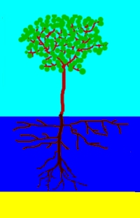 | 1) A deep irrigation is applied to fully wet out the entire root zone. No water should pass beyond the roots. | 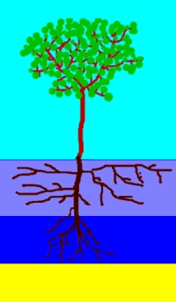 | 2) The plant has plenty of water so will start to use the water from the upper zone.
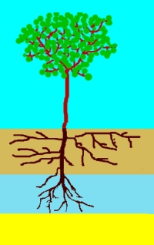 | 3) When the plant finds it a bit more difficult to extract water from this upper layer it will start to take water from deeper in the soil. | 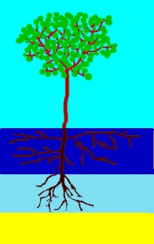 | 4) A shallow irrigation is then applied to wet the upper layer
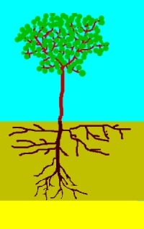 | 5) At some point both the upper and lower layers will be getting dry. |  | 6) This is the time to apply another deep irrigation.  The soil deeper than the root zone is allowed to dry out and form a space for salt flushing later.
 | 7) This cycle is again repeated. This process of deep and shallow irrigation ensures that the plant always has the best condition for growth. | 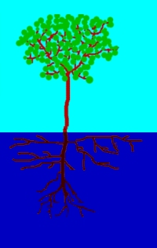 | There is always some salt in the irrigation water. At some point in time a flushing irrigation will be required to move this salt beyond the plant.

I-Planner software

A software program called I-Planner does all the calculations to implement the process. It used to calculate the true crop factor and water holding capacity of the soil. The user then selects either single of dual cycle mode and the programs automatically calculates out when to irrigate and how much water to apply.

The entire soil profile is filled by applying a major irrigation. When the top layer of soil has dried out to the refill point a smaller irrigation is applied which will wet out this top layer but not reach the lower layers which will still be moist. At this time only about 50% total water holding capacity of the soil will have been used. The amount of water applied should not refill the profile, typically only 40% of the full water holding capacity is applied, leaving a deficit of 10%.

A number of these smaller irrigations are applied, typically about 5. This will maintain the upper soils moist but allow the deeper soil to progressively dry out. A larger irrigation is then applied to refill the entire profile.

The program I-Planner does all the calculations, so a practical irrigator does not need to worry about doing any calculations. The theory is described below for those interested.

Measuring crop factor and water holding capacity

 | To irrigate correctly we need to know the amount of water the plants are using and the water holding capacity of the soil. Many such values are available in the literature, however there is a major problem; - every farm is different the topography, hills, facing north or south, the row spacing and the size of the plants and the type of soil.  Literature values provide a valuable guide but what is really needed is a simple way all growers can find out accurate values, for their farm, by themselves.

Basic scheduling theory

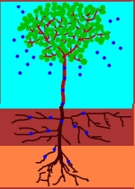 | Plants use water as a way of transporting the nutrients they need from the soil. They use the sun to provide the energy; water evaporates from the leaves creating a water tension (intermolecular forces) to lift water and dissolved nutrients. The nutrient solution enters the root system by osmosis, e.g. water moves from the weak solution in the soil into the stronger solution in the roots.  If the nutrient solution is too strong the roots cannot extract the solution from the soil.  The water evaporates leaving the nutrients for the plant. The amount of water used in the plant tissue is minuscule in comparison with the water evaporated. Water is not actually consumed by the plant; it is lost to the air by evaporation.
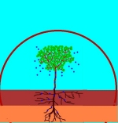 | In a closed container like a terrarium no water is used, it is simply recycled.  The weaker the nutrient solution, the more water is used. The plant responds by increasing the leaf area. The stronger the nutrient solution in the soil the smaller the amount of water needed to provide the plants nutrient requirements, allowing more energy for fruit and carbohydrate production.  The aim of irrigation is more than simply ensuring the plant has enough water, it is to manage the way the plant grows by controlling the amount of water available and the strength of the nutrient level in the soil.

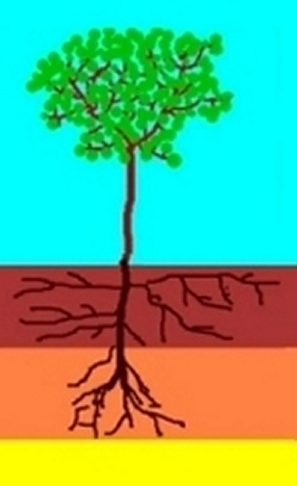 | Some plant such as lettuce have a small root system, but many of the larger plant have two distinct root systems, fine feeder roots in the nutrient rich upper zone and deeper tap roots. The plant will extract nutrients and water, using the fine upper feeder root system, giving rapid growth, while moisture is available. When this is exhausted the plant will still survive, using the deeper roots, but has little growth.  Irrigation should be regularly applied to the upper zone, with less frequent deeper irrigation's ahead of hot spells, to ensure the plant survives, this is called dual cycle or when coupled with weather forecasts anticipatory irrigation.  The key aspect of irrigation scheduling is to control the irrigation depth, by knowing how much water to apply.

Measuring crop factors

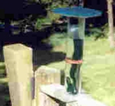 | The amount of water a plant uses depends on the weather, so we cannot say that this plant uses 1.5 litres per day. Instead we use a ratio called a crop factor which is the ratio of the water used by the plant to evaporation.  This picture shows a simple manual gauge which is as easy to read as a rain gauge. It works exactly like a plant. Water in the container (like water in the soil), travels up the wick (like the trunk) and evaporates from the disc (like the leaves). It is a cheap and easy way for growers to measure their local evaporation. Automatic versions and data from conventional evaporation pans are readily available.  Evaporation data is very reliable and cheap (often free).

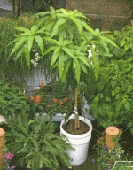 | Crop factors have been traditionally measured by growing a plant in a pot and weighing to find out how much water has been used. The problem is that we measure the amount of water used in litres, but we measure evaporation in mm so we have to convert litres to mm by using an area.  1 litre per square metre is 1 mm. But what is the area, the area of the pot or the area of the canopy or what? We will get a different answer for the crop factor depending on how we choose our area.

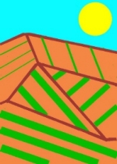 | What about in the field, when we have row crops, what area do we use then? Closely spaced plant will obviously use more water than widely separated plants. If we choose the wrong area we may end up by applying totally the wrong amount of water. Problem!  Slopes facing or sheltered form the sun, exposure to the wind, these all affect crop the factor.

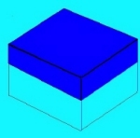 | We would like to be able to measure the real crop factor directly in the field. This may seem simple with modern soil moisture sensors but there is a catch, called wetted volume.  If we irrigate into a water tank we could easily calculate out how full it would get by converting from litres to mm. (1 litre = 1mm/square metre) however when we irrigate into soil we do not know how far the water will penetrate into the ground, this depends on the pour spaces in the soil and how much water is there already.

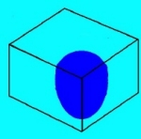 | In practice we cannot apply water uniformly over an area, with dripper systems in particular we only wet a small volume, but we have the same problem with all irrigation systems.  There is no simple way of determining the wetted volume. Plants to do take up water uniformly from the soil, they will extract water from the surface layers where the roots are most powerful first.  The fact is that soil moisture is just not uniform, and water does not readily move through the soil, variable water distribution is one of those things we have to learn to live with.

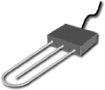 | What can we do? Modern soil moisture sensors give an accurate reading of soil moisture, in what is called their sphere of influence. This varies but 300 mm would be typical. In theory we could use a large number of sensors to measure the entire soil volume but this is just not practical, we need to think of a different way.

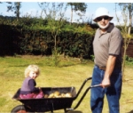 | The answer is adaptive learning. This is me with my grand daughter Kate. Now she knows all about adaptive control, it is how we all learn to stand up and walk, and later drive cars or fly airplanes.  We do not learn to walk by understanding the physiology of our bodies and the complex engineering which enables us to balance and move on two legs.

 | We just give it a go, bump into things, fall over, have a little cry and gradually get it right.  We can do exactly the same with irrigation and learn the crop factor. We can call this process error correction, (or mathematically predictor corrector schemes). Make an estimate, measure the error, correct the error and retry. Kate knows all about this and she is only 2 that's how simple it is. (She is very cute too).

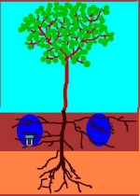 | There are two methods. The first uses soil moisture sensors. One sensor is placed at the target irrigation depth (or if dual cycle irrigation is used you will need one probe for each depth).  You simply start to irrigate using your current best estimate of the crop factor. Simply multiplying the accumulated evaporation since your last irrigation by the crop factor, and converting this to litres based on the anticipated wetted area and then to run time. You would normally use I-Planner to do this for you.  You need to measure and record the soil moisture reading just before and some time after irrigating.

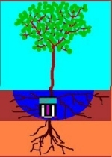 | You simply enter the two soil moisture values, together with the evaporation and irrigation amounts into I-Planner which automatically calculates out the error function; corrects the crop factor which, with your approval is entered into the data base.  Every time you irrigate (or when you want) I-Planner will automatically adjust the crop factor. As the plants needs changes, with the season or growth, the crop factor is automatically adjusted. It simply does not matter what your row spacing or the wetted area is, I-Planner will automatically adjust to give you the correct crop factor.

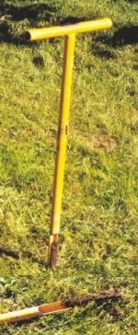 | The second method is based on measuring irrigation depth. Some time after irrigation you simply measure how far the water has soaked into the soil, using a simple auger or soil sampler as shown, and enter this depth into the program. Applying a known amount of water and seeing how far it soaks into the soil is one of the simplest and most reliable way of measuring soil moisture.

Measuring water holding capacity

Water holding capacity is the amount of water in the soil between field capacity and when the plant just starts to go into stress.
It depends on the type of soil, how effective the plant is at extracting water from the soil and the wetted volume.

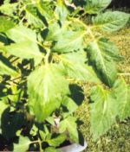 | Different species of plants have widely varying ability to extract water from the soil. The tomato plant shown was clearly suffering from water stress yet a soil sample showed that it was still quite moist. Look for signs of stress such as like leaf wilt, or preferably use a plant moisture sensor.
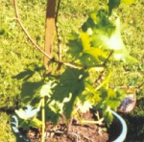 | The grape vine was showing no signs of stress yet a soil sample showed it was dry and crumbly.  The grape vine is far more capable of extracting water from the drier soil (e.g. the onset of wilt occurs at a lot lower soil moisture level). Vines also have a much larger root system e.g. they are using a large volume of soil so the effective water holding capacity of the soil for a vine is much larger than for a tomato.

Dripper systems have a relatively small wetted area giving small water holding capacity while sprinklers and flood have much larger wetted area and hence higher water holding capacity.
As the plants grow they can access a larger volume of soil so the water holding capacity goes up.

Irrigate to target depth | To measure water holding capacity apply an irrigation until the water reaches the target depth, checking using a soil moisture or depth sensor after allowing time for the water to soak.  The soil is now at field capacity. You may not know the actual amount of water in the soil at this moment, (this depends on the field capacity of the soil and the wetted volume). This does not matter, simply think of the soil as full and use this as your reference point.

Measure evaporation | Measure your local evaporation. Let I-Planner calculate the accumulated evaporation since your last irrigation by simply adding up each days reading. (If using the manual gauge just read the accumulated evaporation directly).

Monitor plant for stress | This is best done using a plant moisture sensor. Look for a reduction in moisture plant levels since the soil was at field capacity.  Alternatively you can simply look at the plant for the normal signs of stress, e.g. leaf droop etc. This only occurs after the plant is well into stress and has lost production.

estimate water usage since last irrigation | You then simply read the water deficit in I-Planner and that tells you the effective water holding capacity of the soil.

Water holding capacity = deficit when plant just starts to stress

Practical scheduling

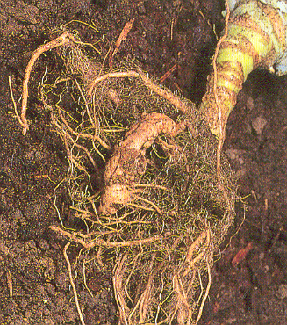 | The first step is to decide the irrigation depth. Digging a hole and having a look is a good place to start, but the currents roots may be more a reflection on you past irrigation practices rather than where they should be.  The top soil horizon, typically 300 mm deep is the most critical, this is where the nutrients are and where you should be regularly irrigating.  You may want to irrigate the deeper zone when water is available to build up a reserve for hot weather. Use the dual cycle approach.

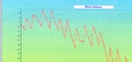  Graph of mm of water below full. This is far more useful than a simple soil moisture graph. | Now we need to settle on a starting crop factor. If you do not have an estimate then simply keep on irrigating as you normally would but enter the evaporation's and irrigation's into I-Planner. This will tell you what crop factor and water holding capacity you are currently using.  The software reads evaporation, water applied and soil moisture data, and displays water content in mm below full (when wetted volume is at field capacity). The grower knows exactly how much water to apply to refill the profile at all times.

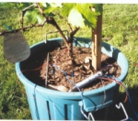  Logging soil and plant moisture.  This plant moisture sensor measures change in moisture since soil was at field capacity | Using a soil moisture or depth sensor see how deep the water is penetrating after irrigating, enter these values into I-Planner and see what crop factor is recommended. You may decide to wait for values from several irrigation's before adopting this value.  I-Planner will tell you the amount of water you have to apply to reach the target depth so you will not waste water if you irrigate more frequently than strictly needed.  When you have a stable crop factor you can increase the water holding capacity setting in IIS-Planner to increase the time between irrigation's.  You can irrigate at any time up until the maximum deficit has been reached and you should apply the amount of water equal to the deficit.  You do not need to be regularly inspecting soil moisture reading to see if it time to irrigate, only before and after each irrigation. With the correct crop factor the evaporation data I-Planner will tell you how much available water is in the soil.
For more information or copies of I-Planner give me an email on
mailto:colinaus@bigpond.net.au

