WaterRight

To schedule your irrigation properly you need to know how much water your plants are using and how much water is in the soil. Once you know this you can

-ensure maximum plant production by maintaining soil moisture levels
-control the water distribution at deep and shallow levels using
-vary the water content of the soil to anticipate hot or wet weather
-manage fruit quality and set by applying controlled water stress. (RDI)

WaterRight is a system which uses irrigation depth sensors, accumulated evaporation meter and adaptive software to learn your plants water use and so provide effective irrigation scheduling.

Here is how it works

1. Decide target irrigation depth

Decide the irrigation depth ensuring the root zone is thoroughly wetted, not too shallow so water is lot by evaporation or too deep so water is wasted by passing beyond the roots. | 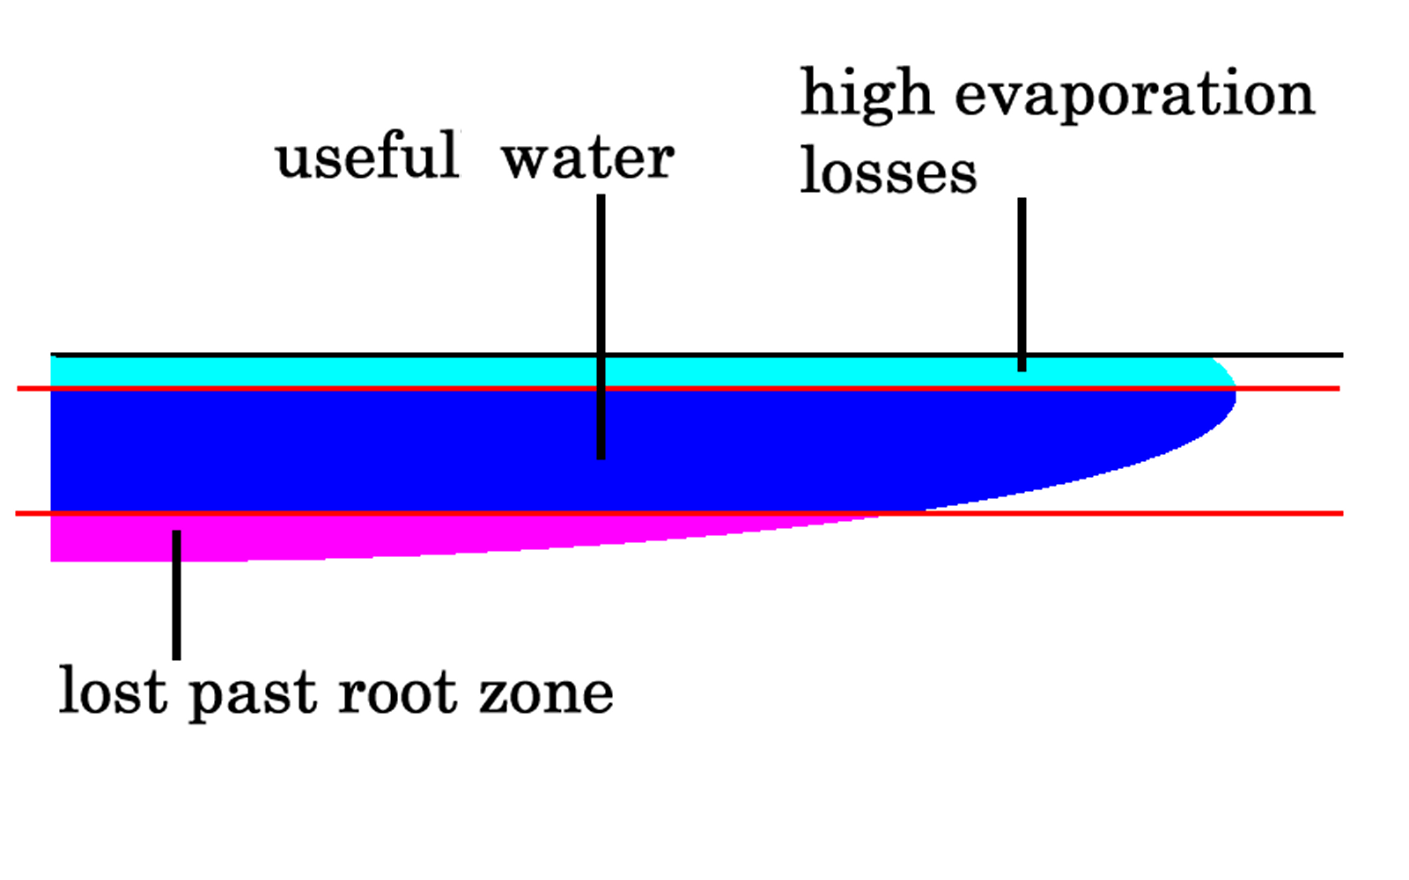

You may wish to vary irrigation depths by using small and large irrigations

If you look at the moisture in your soil you will find the top soil may be quite dry but the deep soil is still wet.  Most nutrients are in this top soil so it pays to apply a shallow irrigation even though there is still some water deep down. | 

After several shallow irrigations the deep soil will be drying out. This may take four to five irrigations |  | Then apply a larger irrigation equal sufficient to wet the full depth of the root zone so the whole profile is thoroughly wetted. | 

2. Measure irrigation depth

Your irrigation depth meter tells you how far the water has penetrated into the ground after irrigation.  Push the stainless steel probes into ground and take readings before and after the irrigation.  Using WaterRight you will learn how much water to apply but to start you can simply apply water until the required irrigation depth ahs been reached.
  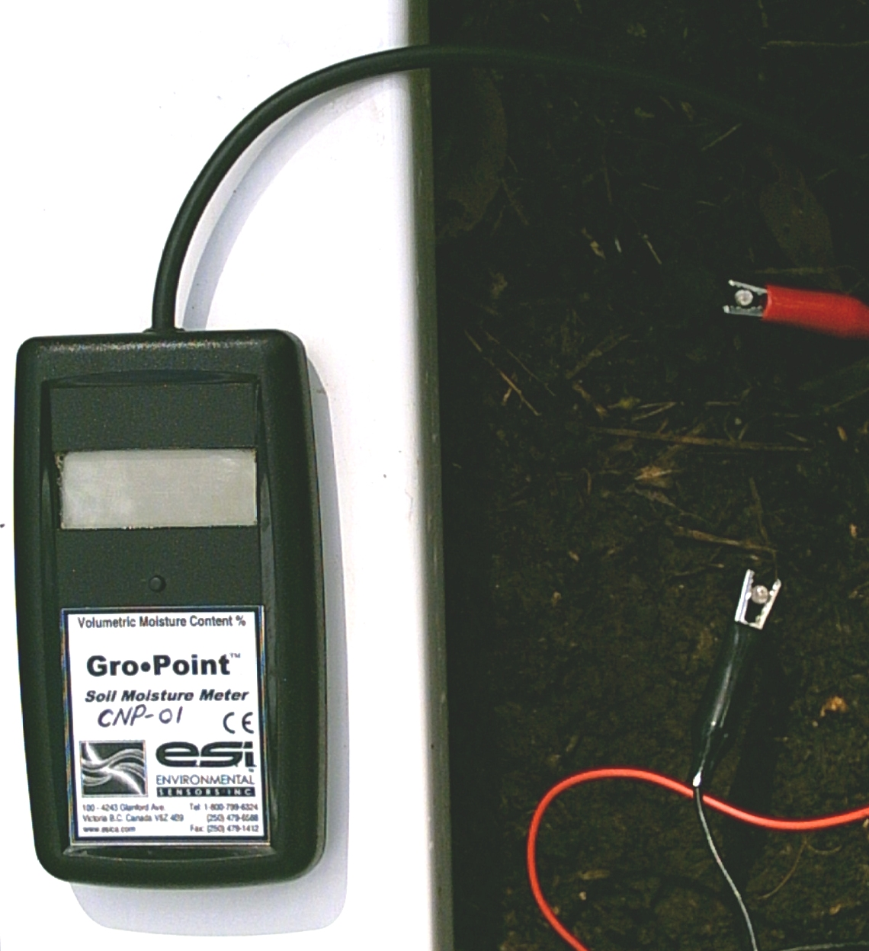

3. Measure the evaporation before you need to irrigate again.

Fill your Magic Mushroom evaporation meter when you irrigate.  You can place the rubber band marker to indicate the accumulated evaporation before you may need to irrigate  When WaterRight has learned the water usage of your plant it will tell how much evaporation to allow between irrigations.  To start you can make a first estimate of the evaporation by dividing the root depth by 20 e.g. if the root depth is 200 mm your first estimate of accumulated evaporation would be 10 mm.
  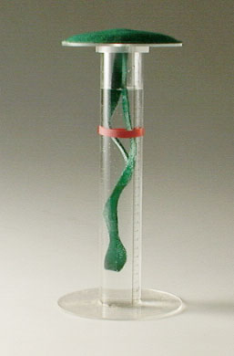

4. Use WaterRigtht to calculate plant water usage

Enter the evaporation, water applied and irrigation depth data before and after irrigation into WaterRight, then use the crop factor calculation to determine plant water use. This may change over time as your plants grow, so you need to do this regularly.

The water use table will show you exactly how much water you need to add at any time to refill the profile. Use the full irrigation switch to refill the profile.

With deeper rooted plants it is better to use the partial irrigation switch which will keep the top zone moist while allowing the deeper root zone (which uses less water) to dry out. When the depth sensor shows that the deep soil is drying out simply use the full irrigation switch to wet out the deeper zone. This will not stress the plant as there is always moisture available.

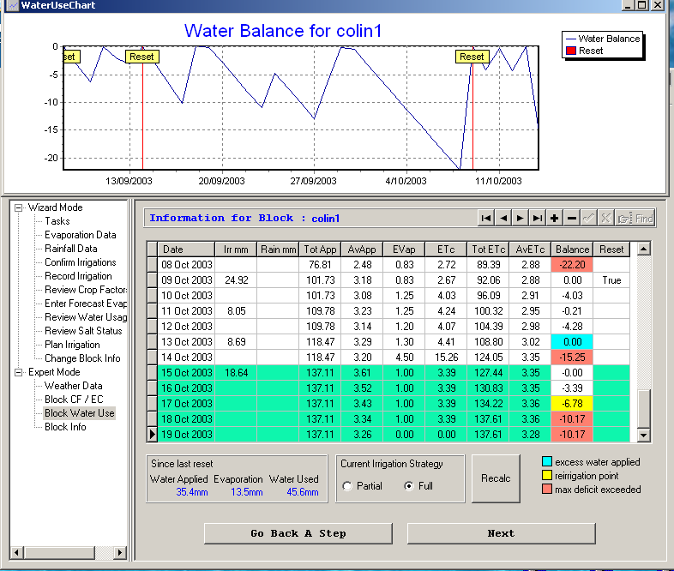

WaterRight table and graph showing water balance. The red indicates that the maximum deficit has been reached; this means a loss of production. The yellow indicates that it is a good time to irrigate, well before the plant goes into stress.

The blue indicates that water has passed beyond the root zone. Allowing the soil to get too dry and then over irrigating is common fault in irrigation management.

You can also use the partial irrigation switch to control fruit quality by applying controlled stress to the plant. Allow the deep tough roots to dry out but ensure that the delicate surface feeder roots do not become too dry as this will damage the root structure. You can use your sensor to measure the start of stress in the plant by inserting electrodes into the plant.

5. Determine maximum water deficit

You can determine the maximum allowable water deficit in the soil by looking at the plant for signs of water stress and looking at the water deficit in WaterRight. However growth will be reduced before well before the typical signs of plant stress eg leaf droop are seen. To avoid loosing production you should maintain the deficit in you soil well above the maximum deficit.

If you really want to deliberately stress the plant you can use your sensor to indicate the onset of stress before these visual signs.

Plants like tomatoes and have limited capacity for extracting water from the soil are so very sensitive to water stress.  Leave droop is an obvious sign of water stress yet a soil sample shows that there is moist. | 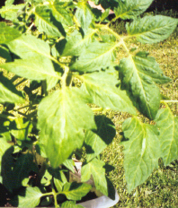

By contrast this grape is showing no signs of stress yet the soil is really quite dry and falls of the auger when a soil sample is taken. | 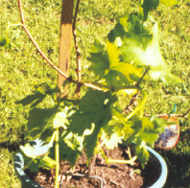

Plant moisture sensors can be used to indicate the onset of plant stress before there are any visual signs of stress on the plant.  The minimum deficit allowable in the soil depends on the soil type, the wetted volume and the ability of the plant to extract water from the soil.  It can be measured by reading of the deficit form the program ‘WaterRight’ when the plant just starts to go into stress.  The deficit should not be allowed to drop to the maximum water deficit as this will hold back growth, typically irrigation should be applied when the deficit has dropped to half the maximum, unless it is required to deliberately stress the plant to control fruit set or quality. Even then the upper soil containing the fine feeder roots should be kept moist. | 