Making the most of water

Micro flood operating manual

Copyright Colin Austin 29 April 2003

What is Micro flood? Efficient, low cost means of delivering water to plants, without under or over watering. In its simplest form, micro flood irrigation works under gravity using small volumes of water, and low cost thin walled pipe.

In areas where there is limited supplies of water and porous soils it is the only economically viable way of irrigation. While low cost is a major feature of micro flood, it was developed to satisfy the horticultural requirements of applying water in the most effective way for plant growth and to minimise environmental damage of irrigation particularly salinity and nutrient run off.

 | It works by saturating the upper layer of soil by applying water rapidly to a small area. This gives a good even spread of water. |  | As the water soaks into the ground, it sucks fresh air into the soil profile, giving well aerated soil, ideal for plant growth
.

About this manual

This manual is designed to

- estimate the area of land that can be irrigated from available water

- plan the irrigation layout

- choose appropriate materials and components

- plan and monitor irrigation scheduling

- take into account social and water use principles

It is born of experience in Australia and World Vision Ethiopia’s Humbo Area Development Program

Index

Section 1 ‘Why Micro flood?’ focuses on the horticultural aspects of irrigation.

1.1 Why Micro flood
1.2 Plant growth and water
1.2 Plant growth and water
1.3 Aeration
1.4 Water and nutrient concentration
1.5 Water distribution
1.5.1 Gravity and hydraulic pressure- causing rapid movement
1.5.2 Surface tension- causing slow movement
1.5.3 Evaporation, condensation and osmosis- causing very slow movement
1.6 Water staying put
1.6.1 Flood- horizontal flow controlled- depth out of control
1.6.2 Drip- depth controlled- horizontal flow out of control
1.7 Aims of irrigation
1.8 Improving irrigation- Micro flood
1.9 Comparison with other irrigation systems
1.9.1 Flood and drain
1.9.2 Flood irrigation
1.9.3 Drip
1.9.4 Sprinklers

Section 2 Micro flood in practise, describes the general layout of the systems

2.1 Micro Blocks and sequential irrigation
2.2 Timing and flow
2.3 Types of micro blocks
2.3.1 Row crops
2.3.2 Pastures
2.3.3 Vegetables
2.4 Switching flow using risers and tilt valves
2.4.1 Risers
2.4.2 Tilt valves
2.5 Integrating micro block into a farm layout
2.5.1 Fields
2.5.2 Micro blocks single rows
2.5.3 Micro blocks in multiple rows
2.6 Land forming

Section 3 Designing a micro flood system, shows how to calculate the land area and pipe sizes

3.1 Design service
3.2 Overview of design procedure
3.3 Design calculations
3.3.1 Calculate total water requirements and average flows:-
3.3.2 Primary pipe
3.3.3 Size and number of micro blocks
3.3.4 Furrows or surface irrigation
3.3.5 Testing flow on your soil type
3.3.6 Secondary Pipes
3.3.7 Tertiary lines
3.3.8 Selection of materials
3.4 Summary of what we need to know;-

Section 4 Operation and scheduling, describes how to manage the system and schedule irrigation

Section 5 Environmental aspect of irrigation, considers how irrigation may affect the environment, particularly how to manage salinity.

Section 6 Social aspect of water policy, discusses how implementing irrigation scheme can affect the local community and what steps need to be considered to ensure equity.

Section 1 Horticultural requirements

1.1 Why Micro flood

Most large scale irrigation scheme employ conventional flood irrigation, perhaps the oldest form of irrigation. Because flood irrigation is relatively cheap it is used to water large areas of land around the world. Even so it is inefficient and wasteful of water, an increasingly scarce resource. In many regions improper management of flood irrigation has resulted in loss of farm land from salting and damage to the environment.

 | Large losses of water are incurred in open and unlined channels through evaporation and seepage. Even more water can be lost in the field, particularly if soils are porous. In order to flood the whole field quickly, large volumes of water are released into the field. Inevitably soil near the water inlet is saturated before the whole paddock is irrigated.
 | Typically plant growth near the inlet suffers from over watering while plant further down the field may suffer from under watering.  Micro flood irrigation overcomes the inefficiencies of conventional flood irrigation at a low cost, a fraction of conventional high pressure systems like drip and spray.

Micro flood irrigation also makes possible the utilization of small water sources not normally considered viable for irrigation.

1.2 Plant growth and water

Plants grow best with an optimum water level, too much or too little water stunts growth.

Just because rain is natural does not automatically mean than rain is the best for plant growth. Floods, drought, prolonged wet periods present challenges for plant life. However crops do grow best with particular rainfall patterns, particularly the spring showers, producing more crops with less water than even our best irrigation.

Look at the phenomenal growth that occurs with good spring showers. It rains, sometimes quite hard for a short period, may be for 10 minutes to 30 minutes, stops followed by a period of warm sun followed by another shower. How long it rains and the period between rain showers can be quite random but the plants grow vigorously, just bursting into life.

Why? What are the mechanics which make these spring showers so productive? What can we learn from this which will help us irrigate better?

The reasons are;-

natural aeration
distribution of water
nutrients, particularly nitrogen in the rain.

Aeration

Plants need water, but they also need air and nutrients to grow well. Roots produce carbon dioxide and ethylene which inhibit growth.

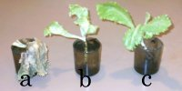 | Plant a (left) was standing in water which was not changed  Plant b (centre) was standing in water which was changed daily  Plant c (right) was standing in air only but roots were soaked in water daily  Conclusion, plant roots need both air and water

 | Spring showers expel stale air from the soil. |  | Fresh air is sucked into the ground as the water drains away creating a natural breathing action

Light and heavy showers will wet the soil to different depths so there is always some layer of the soil which is near the ideal moisture level. The soil is kept moist without becoming water logged and naturally aerated ideal conditions for growth.

It is not possible or even desirable to maintain the moisture level totally constant. Plant undergo complex chemical reaction as they extract oxygen and carbon dioxide form the air, nutrients from the soil and expelling waste gases, particularly carbon dioxide and ethylene, from the roots.

The soil needs to exchange these waste gases for fresh supplies of oxygen. Cyclic application of water actually makes the soil breath. The water actually expels the stale air from the soil, and as the water drains away or is consumed, fresh air is sucked into the soil. This cycle is an important part of plant health.

1.4 Water and nutrient concentration

The amount of water transpired by a plant far exceeds the amount of water actually retained in the plant as part of its structure, which by comparison is negligible. Why do plants consume such vast quantities of water? Simply to extract nutrients from the soil. Water evaporates form the leaves, leaving behind a more concentrated nutrients solution for the plant to use. As water evaporates from the leaves it drags (by intermolecular forces between water molecules) more water, containing nutrients dissolved in the water from the roots.

Water is simply a means of transporting nutrients form the soil to the plant. Applying excess water does not automatically lead to improved plant growth, it can have exactly the opposite effect, diluting the nutrients in the soil, which means the plant has to extract more water, which is then wastefully evaporated, simply to access the nutrients.

At the other extreme if there is not enough water in the soil the nutrient and salt concentration increases and will eventually reach a higher level than in the plant. Osmotic pressure then will actually pull water out of the plant, which will undergo stress.

1.5 Water distribution

Water should be uniformly distributed throughout the soil. Water does not magically redistribute itself; it moves to obey the fundamental laws of physics.

1.5.1 Gravity and hydraulic pressure- causing rapid movement

Gravity is always acting to pull water downwards.

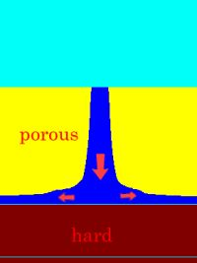 | When the soil becomes saturated it will form a column of water which develops a hydraulic head or pressure which will literally force the water through the soil in the easiest route, often forming an inverted mushroom when the water meets the deeper compacted soil

.

Gravity and pressure can lead to rapid water movement.

1.5.2 Surface tension- causing slow movement

Surface tension will always attract water to the smaller pores in the soil, this resists the water draining from the soil by gravity and may cause some slow lateral movement or it may resist vertical movement.
 | The old but still effective bucket and towel trick for irrigating pot plants.  This works by surface tension very slowly transferring water from the bucket to the plants.

Surface tension leads to slow movement of water in the soil.

1.5.3 Evaporation, condensation and osmosis- causing very slow movement

Water can also move by a process of evaporation and condensation in the soil, a sort of surface dew, it can also move by osmotic pressure, even roots will redistribute water in the soil.

Evaporation and condensation and osmotic movements are very slow, much slower than the application of irrigation water.

 | Experiment 1. Hose set to drip. 0.1 litres per minute.  Diameter of wetted circle 300mm. Wetted area does not increase however long the water runs, it just keeps on going deeper into the soil without spreading.
 | Experiment 2. Hose set to maximum 30 litres per minute  Ground is rapidly saturated and water flows over the surface. Circles show how far the water has travels every 5 minutes.  First 5 mins = 4.5 metres  Second 5 mins = 1.7 metres  Third 5 mins = 1.2 metres  Forth 5 mins = .8 metres
 | As the wetted area increases the rate of water loss by infiltration into the soil increases, the speed of the flow front reduces and eventually stops. After that the water stops spreading and all the water is lost to infiltration. The area around the hose is very wet deep into the ground while the edge of the wetted area is only just moist.

The maximum length that the water will flow is called the equilibrium flow length. This depends on the available flow and soil type. Conventional drippers will normally reach this equilibrium flow length very quickly. Conventional flood irrigation should have runs much less than this equilibrium flow length, otherwise the water distribution will be very bad.

1.6 Water staying put

What does all this mean in simple terms? Basically water tends to stay put, and will only readily move when the soil becomes saturated.

1.6.1 Flood- horizontal flow controlled- depth out of control

When we flood irrigate we apply so much water that it totally saturates the soil. We run the irrigation until the water reaches the end of the bay or run. We cannot control how deep the water will penetrate into the ground.

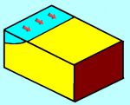 | This shows why flood irrigation is intrinsically inefficient. It starts well with water flowing into the irrigation bay and starting to soak into the ground.  However the next section is irrigated buy water flowing over the first section soaking deeper into the ground.
 | By the time the water has reached the end of the paddock the water at the top has soaked deep into the ground, saturating the soil and with water being lost past the root zone, possibly mobilising salt.  It is not just the loss of water, plants do not grow well when their roots are saturated, so production in lost while the water is soaking or evaporating away.
 | It is essential to apply the water rapidly; this requires large channels which are a major source of waste. Large volumes of water are applied at each irrigation giving a wet and dry cycle which is not productive.

1.6.2 Drip- depth controlled- horizontal flow out of control

When we drip irrigate we apply a lot less water. This does not mean that the water is nicely distributed; the soil under the drip will become saturated and will then percolate downwards only wetting a small proportion of the soil.

Slowing the rate of applying water does not change the wetted volume; it only alters the wetted shape. High flow drippers will give relatively flat wetted profiles while slow flow drippers will give deep but skinny profiles.

We can control how deep the water penetrates into the ground; we have no control on the lateral movement

 | Drip irrigation applies water at a point. It does not spread uniformly throughout the soil but forms a wetted volume, which is at or near field capacity. The size of the wetted volume is determined by the volume of water applied.  The shape of the wetted volume will depend on how the water is applied, the infiltration rate and wicking characteristics of the soil.
 | Running the irrigation for longer will not increase the horizontal spread of the water. It will simply soak deeper into the ground. The initial wetted area will increase until the infiltration rate equals the rate at which the water is applied.  There will be a small extra lateral movement due to surface tension but this is very small and very slow in comparison with initial spread caused by the effects of gravity and infiltration.
 | If the water is applied faster then the wetted area will expand until the infiltration rate equals the rate at which the water is applied. Faster rates and clay soils give wider spread, slower rates and sandy soils give narrow spead.

1.7 Aims of irrigation

Irrigation is not the simple matter it may seem of watering plants.

The challenge of irrigation is to achieve the optimum moisture level and nutrient concentration, coupled with aeration.

The soil must be adequately moist;- ensuring that the nutrient solutions are close to the ideal, not too dilute so the plant waste water, not too strong so the plant cannot extract the nutrient solution from the soil. The soil needs to breath to expel growth retardant and introduce oxygen i.e. purge out the stale air breath in the fresh.

We want to spread the water uniformly throughout the soil so it is uniformly moist, not saturated, however we can only readily move the water through the soil by saturating the soil. This is the difficulty.

1.8 Improving irrigation- Micro flood

This is what micro flood is all about. We apply water rapidly to a small area, like a flash flood, so it covers the surface uniformly. After a short period of time, the top layer will be saturated but water will not have penetrated deep into the soil. At this point we stop the irrigation and allow water from this upper saturated layer to soak deeper into the ground. As it does so it will suck in fresh air, the upper layer will no longer be totally saturated while the lower layers will be moist.

We mimic the natural action of spring showers, first wetting the top layer of soil, then letting the water soak in.

This gives improved plant growth by providing the balance of available water, air and nutrients and is still simple and low cost.

With Micro Flood, irrigation times are very short, between 10 to 30 minutes (depending of soil type and root depth) yet during that short time significant water is applied, typically 5 mm per irrigation.

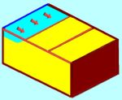 | The concept behind micro flood irrigation is very simple. Water is supplied from a pipe running down the irrigation bay with tap of points along the length.  Laterals, pipes with holes, may be used to spread the water across the bay. Initially it works just like regular flood with water being delivered from the first tap of point.
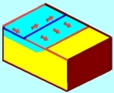 | However when the flow front starts to enter the next section the flow is diverted to the next tap of point, so the water runs through the pipe rather than over the soil.  Only small amounts of water need be applied at each irrigation. The soil is not saturated, so there is no loss of water and the soil is maintained moist which gives optimum production.
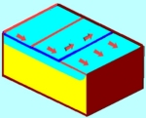 | A flows are small water can be delivered economically through small pipes avoiding seepage and evaporation losses.  Up to 40% extra production can be obtained from the same volume of water, without causing environmental damage.

The length of the micro blocks should be much less than the equilibrium flow length to ensure a good water distribution.

Switching flow to the next micro block should occur after the flow front has entered the next micro block. This will ensure that the water distribution over each micro block is uniform.

1.9 Comparison with other irrigation systems

1.9.1 Flood and drain

The closest conventional irrigation system is the old flood and drain system, used with pots plants this still give the best water distribution. Plants are totally immersed in water (often containing nutrients) then allowed to drain. Flood and drain systems are now widely used in hydroponics by pumping water in and out of the bottom of the container.

The mechanics of flood and drain have a lot in common with spring rains, a natural flushing action, in which the soil breaths. The water distribution is uniform, moist rather than a saturated.

The problem is of course that you cannot just pick up a field and lower it into a lake.

Micro flood applies the principles of flood and drain to large areas.

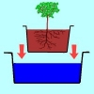 | A plant in a pot is immersed in water, often containing nutrients.
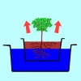 | The water soaks into the soil expelling all the stale air. Many soils, are hydrophobic e.g. do not wet easily. When watered from above eh water can pass through the soil without properly wetting it. With flood and drain the soil is fully wetted.
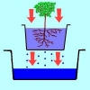 | The port is allowed to drain, as the water drains it sucks fresh air in behind giving ideal growing conditions.  Flood and drain is widely used in hydroponics with water and nutrients being pumped into the pot from underneath.

1.9.2 Flood irrigation

Micro flood is like conventional flood but smaller amount of water are applied more frequently.

Flood irrigation totally saturates the soil, particularly at the top of the irrigation bay where the water may have been soaking into the ground for several hours. Much of this water has to actually soak or evaporate away before the ideal conditions are achieved for growth. At the end of the cycle, before the next major irrigation, the soil is often too dry, again slowing plant growth. Plants only grew well in the middle of the cycle.

Irrigation times are long, taking up to several hours. Significant water is applied (typically up to 50 mm per irrigation). Times between irrigation may be from 7 to 10 days.

Micro flood applies less water typically, 5 mm per irrigation, but irrigation are more frequent, daily or every few days so the soil moisture level is more uniform.

1.9.3 Drip

Micro flood may physically looks like a drip system. The difference is that the flow rates are very high but only for a short period of time. The effect is to get a much wider spread of water e.g. horizontal rather than vertical flow. This is more beneficial for plant growth

Irrigation lines are operated in turn rather than all together. Normally micro flood pipe lines are more widely spaced than those of drip. The system is fed by gravity rather than pressure so there are no expensive pumps and filters which gives a much lower overall cost than conventional drip irrigation.

1.9.4 Sprinklers

Micro flood irrigation and sprinklers both distribute water horizontally; micro flood has much lower evaporation and again is gravity rather than pressure fed.

Sprinklers are often run for long periods of time to minimise evaporation losses while micro flood has shorter but more frequent irrigations.

Section 2 Micro flood in practise

2.1 Micro Blocks and sequential irrigation

To irrigate a whole farm in 10 minutes would requires an impossibly large water flow rate. How is this solved? By irrigating very small areas (micro blocks) one at a time in turn. Automatic valves simply switch the flow from one micro block to the next.

Large areas are divided into micro blocks. Each micro block is irrigated quickly to saturate the upper surface layers. This water then soaks deeper into the soil.

2.2 Timing and flow

The essence of micro flood is the combination of timing and flow.

Short irrigation times controls the irrigation depth, high flows spread the water. These short bursts of intense irrigation are followed by periods of no irrigation to allow the water to soak into the soil.

The required intensity of irrigation is achieved by irrigating small areas at time. Delivery flow may be quite low but the intensity over a small area is high.

An appropriate irrigation time and flow rate is required for each soil type. Porous sandy soils can only be irrigated fast for a short time; clays can be irrigated more slowly for longer.

2.3 Types of micro blocks

The style of micro block depends on the type of crop.

2.3.1 Row crops

For a row crops, such as fruit trees, the field is split up into rows, with each row (or a number of rows) forming a micro block. Each row has its own irrigation line with one or more emitter at each tree. Each row is irrigated in turn until the entire field has been irrigated.

This system looks like a conventional drip irrigation system, but only one line is irrigated at a time. Each emitter has a flow rate at least ten times that of a conventional dripper and flash flood irrigates a circle of may be 2 metres or more diameter.

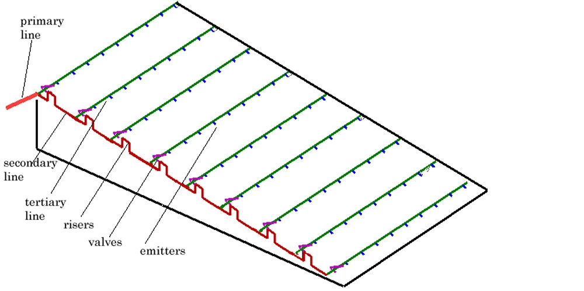 | Diagram showing general layout for row crops

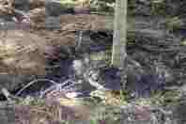 | The best way of irrigating a large tree is to make a ring around the base of the tree and flood the entire ring. This ensures that the whole root systems gets a good watering.  It is far better than a drip which only irrigated a small area.

2.3.2 Pastures

For a crop such as pasture the field is split up into bays, which in turn are split up into micro blocks. Each micro block in a bay is irrigated in turn, until that bay has been irrigated when the system is automatically switch to the next bay where again all micro blocks are irrigated in turn, and so on, until the entire field has been irrigated.

This resembles classic border check irrigation, except that each micro block is fed in turn by a valve. The flow to each micro block may be similar to the flow to feed the entire block in classic border check irrigation. The flow over the micro block may be simple surface flow, directed across the bay by small channels or an irrigation line.

It may look like conventional border check irrigation but it is a flash flood rather than a deep flood.

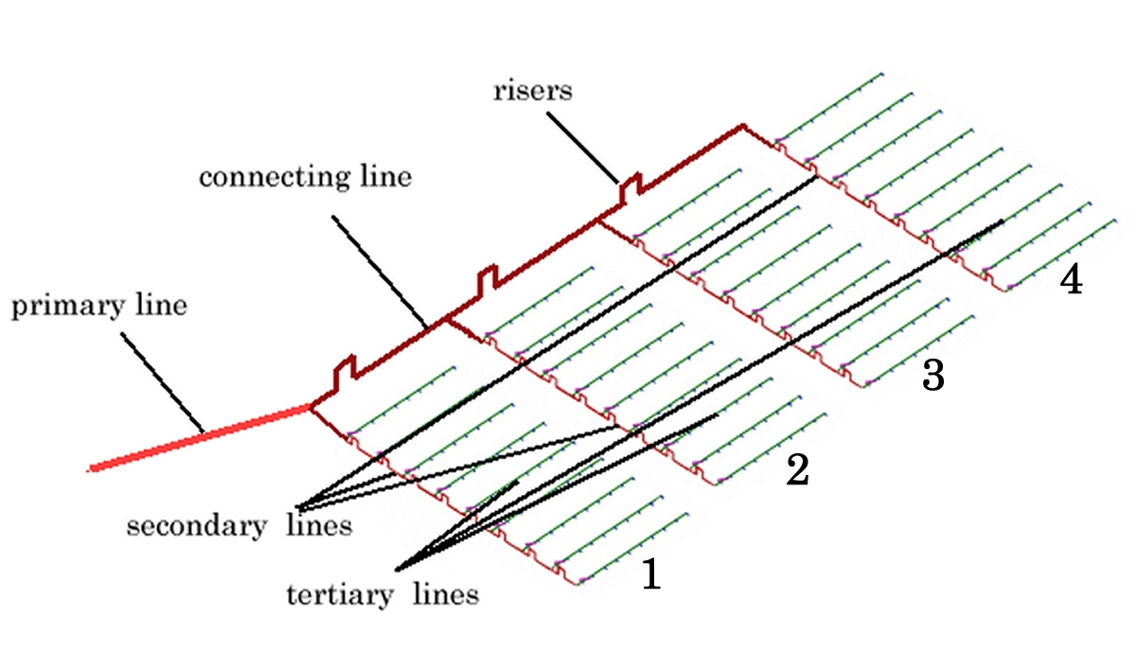
Larger area can be irrigated by using multiple bays. Connecting lines with risers join the individual bays. Bay 1 is irrigated first, when all valves have closed in bay 1 the pressure builds up so the water flows over the riser in the connecting line and bay 2 is irrigated, then bays 3 and 4 etc.

If cattle are grazing the paddocks the lines must be buried and adequately tough to resist damage.
An alternative is not to use tertiary lines and just let the water flow over the surface. There must be adequate flow available to flood each micro block in a short time. Without tertiary lines to spread the water across the bay, it may be better to place the secondary lines closer together.

This layout would be similar to conventional border check irrigation, eg multiple long skinny bays, with the secondary lines running down the borders of each bay.

2.3.3 Vegetables

For vegetables the field may be divided up into bays which are further divided up into micro blocks. An irrigation line, with emitters, runs across the bay from each valve. Each emitter feeds a furrow, dividing the micro blocks up into beds, similar to conventional raised bed farming.

As most vegetables are shallow rooted, smaller blocks with even higher flow intensities are generally required.

 | Preparing a vegetable block. Markers indicate emitters. Furrows have been formed by compacting the soil.  Furrows go one micro block to the next for the whole length of the field. When water has entered the next micro block the flow is switched to the next tertiary line.

2.3.4 Mixed

Plantings in non irrigated land are generally well spread out eg low density. This enables the roots to spread and make better use of rainfall.

Plantings in irrigated land are best closely spaced eg high density as there is plenty of water available for the plants. There will always be some evaporation losses from the soil whether there are plants in the soil or not.

Having a combination of plants with different roots depths give the most efficient use of water. For example shallow rooted vegetables such a lettuce can be planted with say radish under a pepper bush.

2.4 Switching flow using risers and tilt valves

Water is switching between micro blocks by a system of risers and valves.

2.4.1 Risers

The risers direct the water into the tertiary or irrigation lines by simply raising the pipe so the water has to overcome a head. The simplest method is to use an inverted U. Flow is diverted to the next block by closing the tertiary line with a valve which forces the water over the rise.

The total area is uniformly irrigated by sequentially closing each tertiary line in turn after each micro block has received adequate water

2.4.2 Tilt valves

Tilt valves are used to provide automatic operation. During irrigation a tube is slowly filled from a small bleed line connected to the tertiary line. When a certain volume of water has been delivered, the weight of water is sufficient to pivot the tube so squeezing closed the flexible tertiary line.

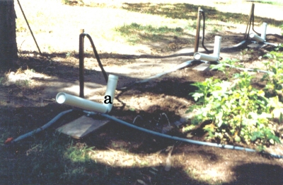 | Before irrigation the valve counter balanced to stay open. During irrigation water is bled into camber ‘a’ which continuous to hold the valve open. It stays fully open throughout irrigation of that micro block.
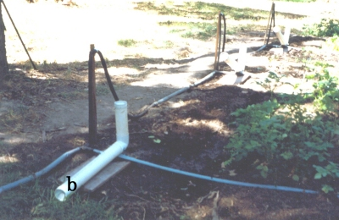 | When chamber ‘a’ is full it overflows into chamber ‘b’. When the weight in chamber ‘b’ the valve ‘tilts’ and the water from ‘a’ flows into ‘b’ creating sufficient force to squeeze the pipe shut. Thew ‘sloshing’ action of the water means the valves snaps from being fully open to fully shut.

The system is totally automatic but can be overridden if needed by manually closing the required valves.

Tilt valves are patented but are supplied by NGO’s such as World Vision, as part of their aid program to developing countries.

Farmers in developed countries can purchase tilt valves from approved manufactures. Purchase a ‘tilt’ valve automatically grants a license to use the Micro Flood’ system.

2.5 Integrating micro blocks into a farm layout

We have described the various types of micro block, we now have to consider how these are integrated together to give a design for a large area. This may be one large farm or a community of farmers working cooperatively.

2.5.1 Fields

The total farm is divided up into fields, each growing different crops or requiring different irrigation schedules so they need to be irrigated independently.

Each field is divided up into a number of micro blocks which are irrigated automatically in turn.

2.5.2 Micro blocks single rows

The simplest layout is to have a single row of micro blocks arranged down the slope. This means that the micro blocks have the same width as the field.

A primary line carries the water to the highest point of the block.

A secondary line runs down the slope.

A tertiary lines runs across the slope. These tertiary lines have holes along the length which apply the water, which runs down the slope wetting the soil.

Each tertiary line has a valve to turn the water on and off.

In many ways it is similar to the traditional Yeomans key line system in which an irrigation channel follows the contour line or with just a very slight fall, but with the channel replaced by a pipe with holes.

2.5.3 Micro blocks in multiple rows

In some cases the field may be very large, much wider than one micro block. The micro blocks are then arranged in rows each having a secondary line which is fed by a connecting line which runs across the top of the field or along a ridge.

This connecting line has risers which are higher than the risers on the secondary lines feeding individual rows.

The field is automatically irrigated, with the all micro block in the first row being irrigated in turn. When all the micro block in this first row have been irrigated the system will irrigated the next row and so on until all the micro blocks in all rows have been irrigated.

2.6 Land forming

There must be some slope for the water to run down hill. Preferably the system is laid out to take advantage of the natural slope. Steep slopes can be irrigated easily, although the irrigation time may have to be kept short.

In some case the field may be virtually flat with no slope. Individual micro block must have some slope so the field is worked into a saw tooth. Slopes of 1 in a 100 are preferred.

In general working the soil should be avoided, this just makes the soil porous so the water flows down through the cracks rather than over the surface. A similar effect can be found with clays which become very porous as they dry.

If soils have been worked it is desirable to irrigate the field several times before planting and let the soil settle. Some rework may be necessary to maintain the slope after settling.

Trees in rows present little problem as the soil will settle and compact, the run lengths are short and the root depth is quite deep requiring deep irrigation.

Vegetables are the opposite, they are shallow rooted, the soil is continuously being reworked. They are best irrigated using compacted furrows. The soil is worked in preparation for planting. A furrow is then formed by compacting the soil, using a wheel or suitable implement. Ideally these compacted furrows should remain in place permanently without reworking.

Run lengths times should be kept short so water does not soak past the shallow roots. If water flow is limited this means short run lengths,

Section 3 Designing a micro flood system

3.1 Design service

We provide a design service to calculate the sizes of the micro blocks and the various pipes. To enable us to undertake the various calculations we need specific information. This section aims to describe this design process and the specific information we need for these design calculations.

3.2 Overview of design procedure

The overall procedure is described below.

For each field;-

Calculate total water requirements and average flows.

Estimate irrigation time based on soil type and root depth of plants

Calculate size and number of micro blocks

Identify the highest point on the field and how to bring water, under pressures or gravity, to that point.

Decide how many secondary lines will be used eg number of bays or strips

If more that one secondary line, decide route of connecting line, typically across the top of the field or along a ridge

Position secondary lines, this is usually down the line of greatest slope

Position tertiary lines, typically across the block on a contour line

3.3 Design calculations

3.3.1 Calculate total water requirements and average flows:-

You will need to decide the size and layout of each field, and what crops you wish to grow.

From this we calculate out the average flow required from

average flow = area * peak evaporation * crop factor/available run time per day

(See Irrigation Scheduling for how to measure real crop factors on site.)

If for example;-
area to be irrigated 1 hectare (10,000 sq metres)
evaporation 5 mm per day
crop factor = 1
available time for irrigation per day was 15 hours then

average flow = 10000 * 5 * 1/(15 * 60) = 55.6 litres/min

These figures have to be checked against available flow rates. If more flow is readily available then it is generally economic to increase the size of the micro blocks and reduce the total time for irrigation. If not enough flow then either the area under irrigation or the peak application of water may have to be reduced.

If several fields need to be irrigated, then adequate time must be allowed for all fields to be irrigated, for example if there are three fields, then the maximum time for irrigation for each field may only be 5 hours

Information needed;-
area of each field
crop and crop factor
expected evaporation and rainfall
available flows and pressures

3.3.2 Primary pipe

Primary pipes transport the water from the water source, wherever that may be, to the highest point of the block. These primary pipes may be gravity fed from a water source from a higher point or pressure fed uphill to raise the water from a lower point.

Water flow continuously through these primary lines (while irrigating).

Pipes are sized using standard hydraulic formulae, for example if we were using a gravity fed system we would need a 50 mm pipe to carry 55.6 litres per minute however a pressure fed system may only need s 19 mm pipe.

Information needed;-

length of primary pipe
available pressure
head (rise or fall)

3.3.3 Size and number of micro blocks

The size and number of micro blocks is determined by the available flow, the length of the irrigation time and the amount of water required per irrigation.

micro block area = available flow * irrigation time/water applied

30 mins is a common irrigation time and 5 mm of water is commonly applied per irrigation

For example if the available flow is 55.6 litres per minute then

micro block area = 55.6 * 30/5 = 333.6 sq metres and

the number of blocks is the total area/area of micro block

number of blocks = 10000/333.6 = 30

The same answer could have been obtained by saying that the total time available for irrigation is 15 hours the time to irrigate each micro block is 0.5 hours so the number of blocks is 30.

Run time depends on the infiltration rate of the soil. Sandy soils may require a shorter irrigation time to avoid water soaking past the root zone. This should be tested beforehand. Shorter irrigation times are achieved by reducing the size of the micro blocks or if water is available by increasing the flow rate.

We need to know
estimated run time.

This depends on soil type and crop. Soils with high infiltration rates and shallow rooted crops require shorter run times.

As a guide this will be

soil type | Run time (mins)
sandy loams | 10
heavy loan | 30
clay | 60

You need to indicate the type of soil and the estimated root depth of your plants; we will then make a provisional estimate of the dimensions of the micro block, flow rates and the run time.

By considering the type of soil and the required root depth we estimate the required application rate, may be 5 mm per hour for a deep rooted plant in heavy clay, 10mm per hour is a typical figure for a good loam, while we may need 40mm per hour for vegetables in a sandy loam.

Information needed;-

type of soil
crops type and root depth
furrow or surface irrigation

3.3.4 Furrows or surface irrigation

Furrows, particularly if formed by compacting the soil rather than trenching, are far more efficient at distributing water.

With furrows we need to know your planned width between furrows, which determine emitter spacing. This would normally be about 750 mm.

We will supply a provisional design; you may need to check that this will work properly.

3.3.5 Testing flow on your soil type

We will make a first estimate of the micro block size, e.g. length and width and the estimated run time based on soil type, then you need to check whether this will work by making a trial with one emitter.

The test is to ensure that the water flows over the surface for the full length in the required time without soaking too far into the ground. This depends on the infiltration rate of the soil and whether the soil is irrigated by furrows or over the total surface.

This is measured directly by running water onto the soil e.g. from a trickling hose or a dripping bucket and watching, noting the time to wet the area and then measuring penetration, normally by digging or using an auger.

You need to decide the maximum irrigation depth which is based on the root depth of the plant. Vegetables may only have a root depth of 100 mm, and the soil may be worked and quite porous, this will require short run times, typically 10 minutes.

Large trees may have very deep root systems but we would not regularly irrigate to the full root depth. We would normally irrigate to a depth of about 300 mm on a routine basis and occasionally apply multiple irrigations to reach the full root depth (see section on irrigation scheduling).

3.3.6 Secondary Pipes

Secondary lines run from the water entry point e.g. the highest point on the total block to the highest point on each micro block, and normally run down the line of greatest slope. They supply water to the tilt valves which sequences the irrigation to each micro block.

They are gravity fed from the highest point and are sized accordingly.

For each secondary line we need to know;-
the length
the fall

3.3.7 Tertiary lines

Tertiary lines feed the water across the block, delivering water by emitters or holes. The number and diameter of holes in this pipe are designed so that the total available flow can be diverted into one micro block at the head pressure slightly lower than the rise in the pipe.

For example with a head of 0.5 metres the flow from a 4 mm hole may be 100 litres per hour. It the available flow is 1,000 litres per hour then 10 or more holes will ensure that the head never rises above 0.5 metres.
We need to know;-
length of tertiary line
required emitter spacing based on plant or furrow spacing (typically 750 mm)

3.3.8 Selection of materials

You need to decide what material to choose for your pipes. Primary lines are usually permanent and if pushing water up hill will be subject to pressure. A pipe with reasonable strength, which is buried in the ground as a permanent installation may be justified.

Secondary and tertiary lines are low pressure. Layflat pipes are very cheap and do the perfectly well. They can however be easily damaged during handling.

3.4 Summary of Information needed;-

Field
area of each field
crop and crop factor
expected evaporation and rainfall
available flows and pressures

Primary pipe
length of primary pipe
available pressure
head (rise or fall)

Micro block
type of soil
crops type and root depth
furrow or surface irrigation

secondary lines
the length
the fall

tertiary lines
length
required emitter spacing based on plant or furrow spacing (typically 750 mm)

Section 4 Operation and scheduling

Classic irrigation scheduling uses the single or deep cycle principle. The water holding capacity of the soil is determined from the field capacity of the soil and a refill point, some value above the wilt point. The soil is allowed to dry down to a refill point, and sufficient water added to refill the profile. This deep cycle does not give optimum growth. Dual cycle irrigation is more productive.

Dual cycle means applying a large irrigation to wet the entire profile then a series of smaller irrigation to maintain the upper soil moist.

Soils will dry down progressively from the surface; dual cycle irrigation maintains both deep and shallow moisture levels without saturation.

This is best managed by calculating out the plant moisture usage, which is done by a process called adaptive irrigation, in which the crop factor is determined by measuring applied water, evaporation and soil moisture. This crop factor is measured for the particular site and is not a generic crop factor which may not the relevant to that site.

Once the water holding capacity has been determined the effective water holding capacity of the soil can be found from monitoring the plant.

Single cycle irrigation is recommended for shallow rooted plants such as vegetables. Evaporation is measured and sufficient water applied to refill the profile. After irrigation, the irrigation depth or soil moisture is monitored to recalculate a revised crop factor. The crop factor is continuously adjusted as the plant grows.

With Micro Flood it is best to set the run time of the valves to apply a fixed volume of water at every irrigation eg 5 mm. The accumulated evaporation between irrigations is then calculated from the crop factor eg the if the crop factor was .8 then the evaporation between irrigations is 5/.8 = 6.25 mm

This is best measured using the evaporation gauge shown and adjusting the marker to the required accumulated evaporation. The gauge is filled after every irrigation and is simply watched until the water level drop down to the marker when it is time to irrigate again.

Dual cycle irrigation is recommended for deeper rooted plants. The soil profile is filled by applying a major irrigation. With Micro flood this is best done by applying several repeated irrigations. A further irrigation is applied before the soil has dried out to the refill point, typically when only half the available water has been used. The amount of water applied should not refill the profile, typically only 40% of the water holding capacity is applied.

A number of these smaller irrigations are applied, typically about 5. This will maintain the upper soils moist but allow the deeper soil to progressively dry out. A larger irrigation, or series of smaller irrigations are then applied to refill the entire profile.

 | Many plants have two root systems. In the nutrient rich upper layer they will have fine feeder roots. If this upper layer is adequately moist the plant can extract all the food and water it needs.  If the upper layer dries out it will use it survival roots to extract moisture. Many nutrients like phosphorus and calcium and not mobile and are absent in this deep layer. While the plant will survive but not flourish.

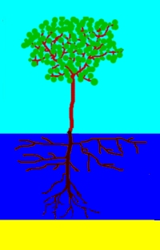 | 1) A deep irrigation is applied to fully wet out the entire root zone. No water should pass beyond the roots. |  | 2) The plant has plenty of water so will start to use the water from the upper zone.
 | 3) When the plant finds it a bit more difficult to extract water from this upper layer it will start to take water from deeper in the soil. |  | 4) A shallow irrigation is then applied to wet the upper layer
 | 5) At some point both the upper and lower layers will be getting dry. |  | 6) This is the time to apply another deep irrigation.  The soil deeper than the root zone is allowed to dry out and form a space for salt flushing later.
 | 7) This cycle is again repeated. This process of deep and shallow irrigation ensures that the plant always has the best condition for growth. | 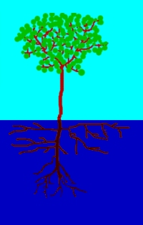 | There is always some salt in the irrigation water. At some point in time a flushing irrigation will be required to move this salt beyond the plant.

Software to calculate plant water usage and the correct irrigation schedule has been developed. (Details are contained in the irrigation scheduling manual.)

Section 5 Environmental aspect of irrigation

Irrigation inevitably reduces flow in the river systems. This can obviously have a negative effect on the natural environment. This may impact the whole community however there is often a failure on the part of water authorities to limit the amount of water that can be extracted for irrigation. This is often seen as a conflict between the needs of irrigators and those of the wider community.

Soil sodification is an overwhelming reason why it is in the interest of irrigators to ensure correct management of the water system as a whole.

Irrigation can be looked upon as a giant evaporation system. All irrigation water contains some dissolved salts, even though the amounts may be very small. Much of this irrigation water will evaporate, but the salt will remain, gradually concentrating in the soil.

If this salt it not removed then the salt will accumulate, the soil will become less productive and eventually will become useless.

This can only be resolved by a two stage process; first the irrigator must apply a certain amount of flushing flow to remove the salt from the irrigated area. This is best done by a series of deliberately designed flushes rather than just applying a little bit of extra water on each flushing.

The salt in these flushing flows will eventually end up back in the river system. There must be adequate flow in the river to remove this salt. If there is not adequate river flow the salt will simply be reapplied back to the land by irrigators further downstream

This can take some time but if not managed correctly will eventually lead to the total destruction of productive land. It is therefore very much in the irrigator’s interest to ensure that the river system as a whole is managed correctly.

Software which calculates the most effective flushing cycle has been developed.

Section 6 Social aspect of water policy

New irrigation schemes are often greeted with a great deal of enthusiasm with often significant incentives for farmers to participate.

History has shown that the long term social implications of these irrigation schemes are overlooked in the initial enthusiasm. Water has often been made available at very low cost and often with little regulation on how the water is managed leading to inefficient irrigation practices.

Over a period of time this can lead to significant social tensions. Members of the community who do not have access to water feel disadvantaged. This may be farmers who missed out on the original allocation of water or other members of the community who see their environment being destroyed.

Once irrigators have become accustomed to low cost and abundant water there can be significant resentment to the introduction of restrictions on how that water is used. As salt level rise there will be an inevitable need for extra water to flush the salt from the land and back into the river then for the river to transport the salt to the sea.

Even though it may be in the irrigator’s long term interest, they can be remarkably reluctant to give up their water for salt flushing.

There needs to be widespread understanding both by the managers of irrigation schemes, the irrigators and the community at large that water is a communal property.

When water fall as rain there is no cost, however water has a value which is sometimes very high. Often water is supplied to irrigators at little or no cost, or at best a cost which only covers the cost of distribution. There needs to be recognition that water is supplied to irrigators, not just so they can make money for themselves, but, to enable them to provide food for the community as a whole.

Managers of irrigation schemes need to recognise a responsibility to educate their irrigators that the price paid for water should reflect the value of the water, not just the cost of delivery. Revenues from water sales should be used to benefit the community as a whole.

