Micro flood, a new way of applying water

Colin Austin

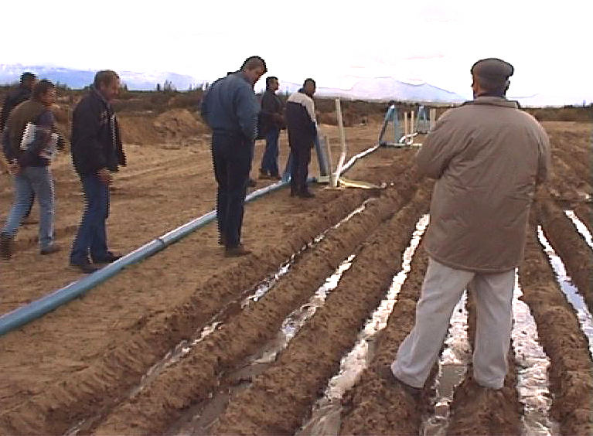 | In August 2003 a group comprising specialists from the department of agriculture, water experts, irrigation engineers and pipe manufactures assembled in the Kouebokkeveld some 300 kilometres north of Cape Town, South Africa, to view a new irrigation technology.

To all appearances it looks like conventional flood irrigation but was apparently achieving the impossible of successfully flood irrigating soil which is essentially blown sand, from relatively small pipes, without loosing water past the root zone. Could this possibly be the most significant development in flood irrigation since the Sumerians 6,000 years ago?

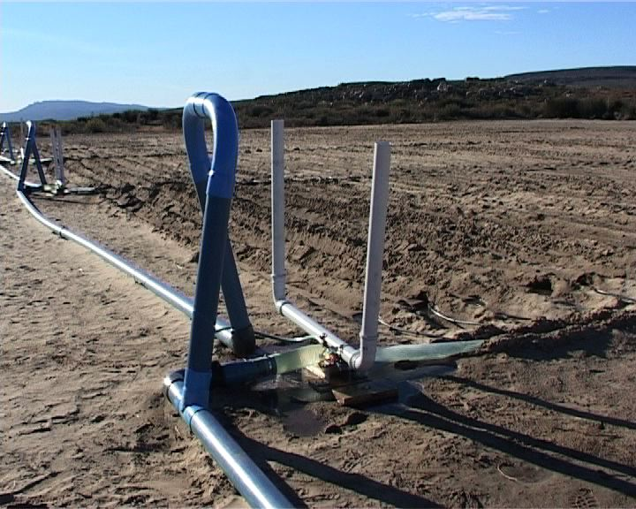 | At first sight the system called Micro Flood looks deceptively simple, nothing more than plastics pipes, bought from the local store, feeding water into small areas in sequence by squeezing a flexible pipe shut by the weight of water.

Could such a simple, even crude, looking system have the potential to bring great increases in agricultural productivity in many areas where hunger is endemic through more efficient use of water resources? Here is the story.

World Vision, an international relief and development agency is constantly searching for long term solutions to hunger. Because provision of relief food is not a long term solution, World Vision sought help to provide farmers with a more efficient way of using limited supplies of water for irrigation.

In areas of limited or unreliable water, increasing irrigation efficiency is not some academic interest, it should be thought of in terms of how many more people can be fed from a finite water resource.

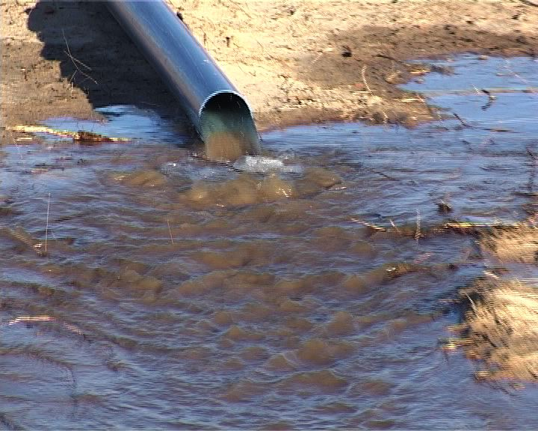 | Much of the world’s water is used by flood irrigation in the less affluent countries which may not have electricity for pumps let alone for computers and moisture sensors. A totally new technology was required that still had to be highly efficient, but be gravity fed and should not require sophisticated electronics.

Advances in technology come from some new understanding. Flood irrigation may appear to be a very simple process yet developing a better understanding of this deceptively simple process has lead to the development of the Micro flood technology.

Imagine a simple garden hose pouring water onto the ground. Immediately under the hose the water will build up forming a puddle, the puddle will steadily get bigger with water flowing over the surface. If we were to poke a screw driver into the ground we would see the hole would immediately fill with water to the top of the hole.

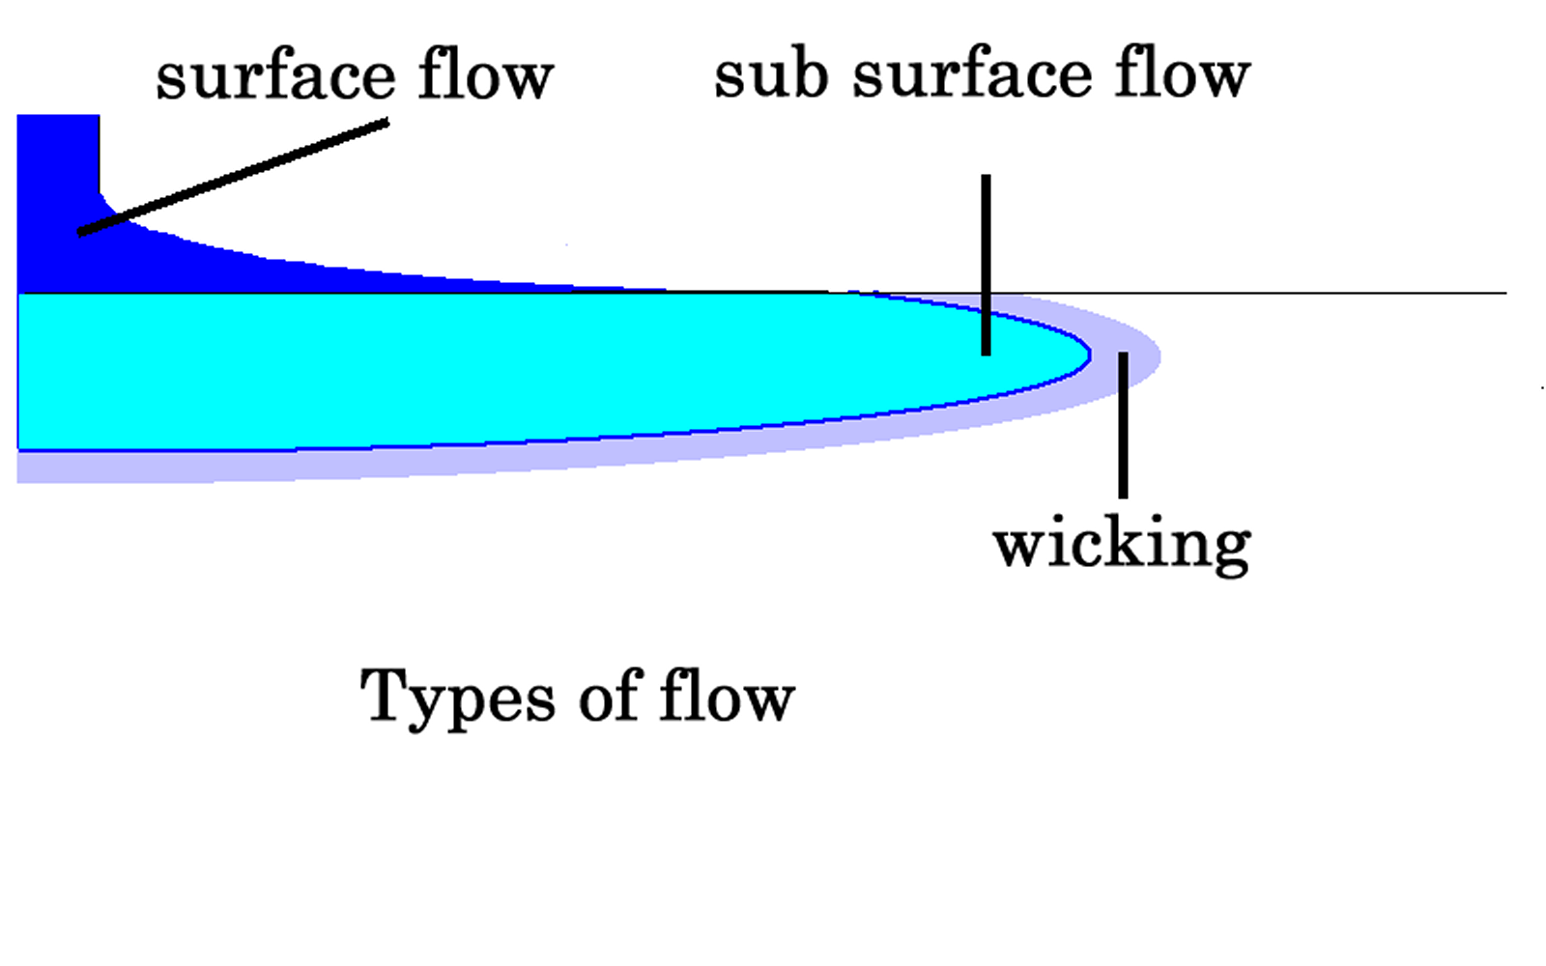 | Initially water flows over the surface. Pressures in the soil build up giving subsurface flow ahead of the surface flow.  Later wicking wets the soil even further ahead of the main flow front.

At some distance from the hose the water stops flowing over the surface but if we were to push our screw driver into the ground the hole would again fill with water but this time not quite to the top.

If we were to make another hole further away the hole would still fill with water but this time would not come quite so close to the surface.

If we made a series of such holes we can see that there is a water line at some angle to the surface. If we did this in a sandy soil the angle would be very steep, may be 30 degrees to the surface while in a clay soil the angle may only be 5 degrees. This flow is subsurface flow resulting from hydraulic pressure.

Now if we make further holes away from the hose we would not see any liquid water in the hole, but the soil would still look damp. If we were to repeat this experiment a number of times on a lawn over a hot dry period we would see a ring of green extending beyond the area where we can actually see water.

There is still water movement but this is caused largely by surface tension but there are other mechanisms at work such as osmosis, subsurface evaporation and condensation and even the plant extracting water from the soil from wet areas in the day time and then returning water by different root systems at night.

Now if we were to dig a trench out from our hose we would see the wetted profile. Under the hose the soil may be wetted to quite some depth, well beyond the root zone. This water that passes the root zone is wasted so the region near the hose or source is not very water efficient. It can also aggravate salinity.

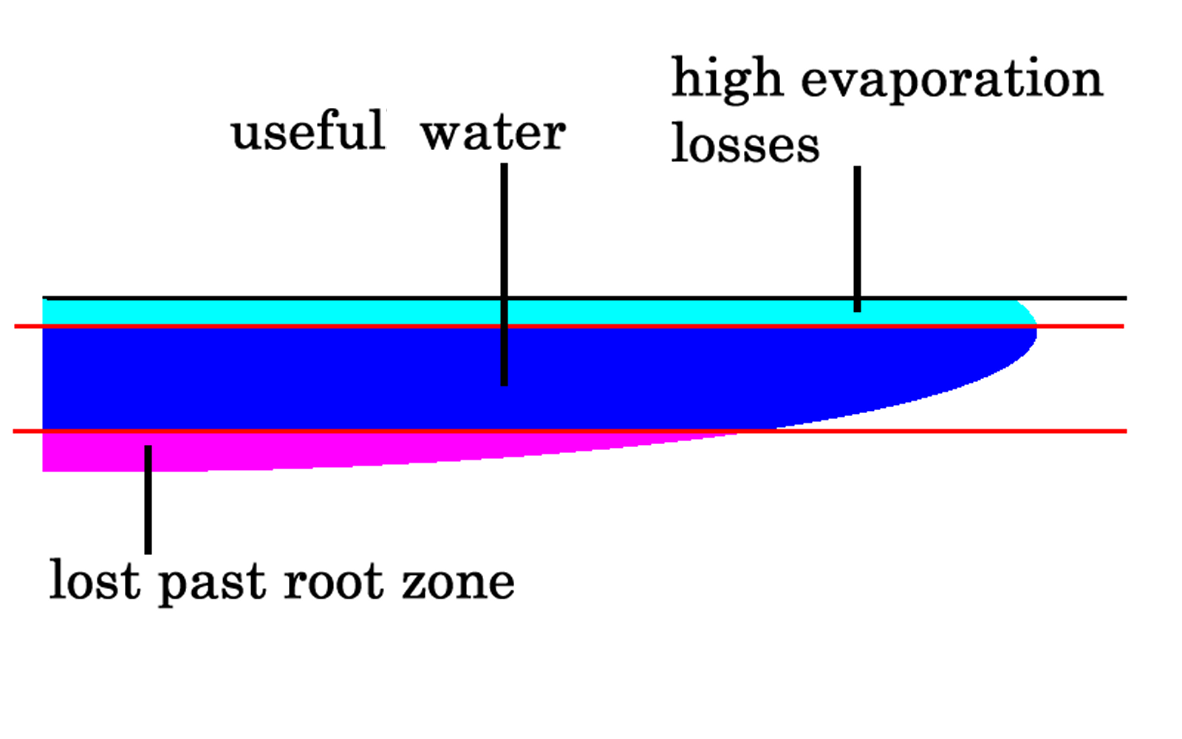 | Shallow water near the surface is largely lost by evaporation; deeper water is lost past the root zone.  Useful water lies in between; the aim is to get water into this useful zone.

Further away the water will have thoroughly wetted down to, but not passing beyond the root zone, so we are making good use of the water in this region.

Even further away water will have only reached just below the surface and will not be properly wetting the root zone. This water will quickly evaporate away so this region where we have only shallow penetration is also not efficient.

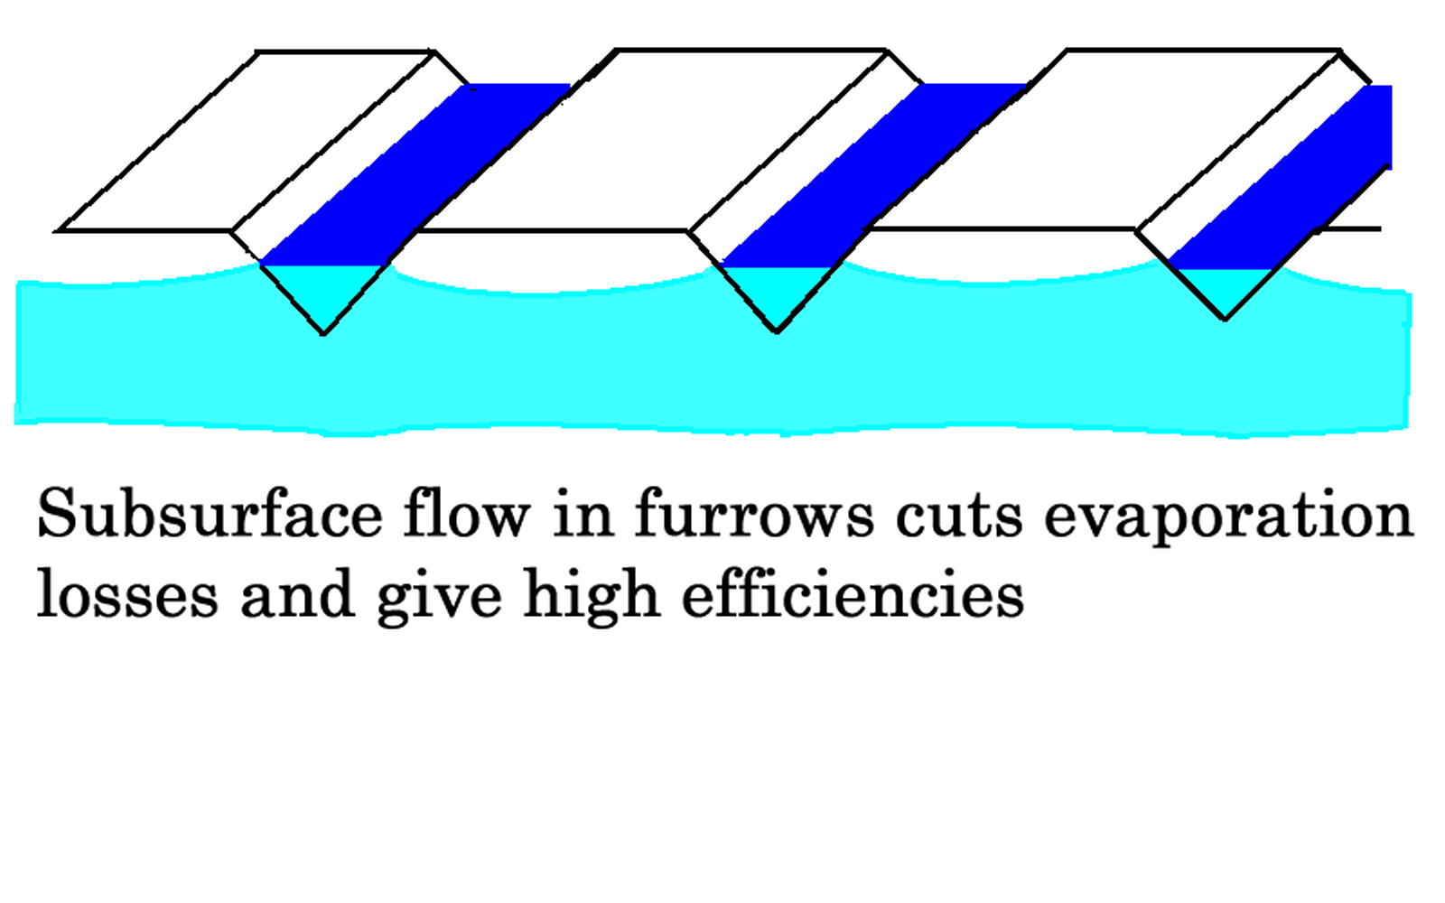 | Furrows are much more efficient as the wetted surface area is dramatically reduced while the subsurface flow wets the soil between the furrows.
Computer software has been developed to calculate the wetted profile.

Sample print out

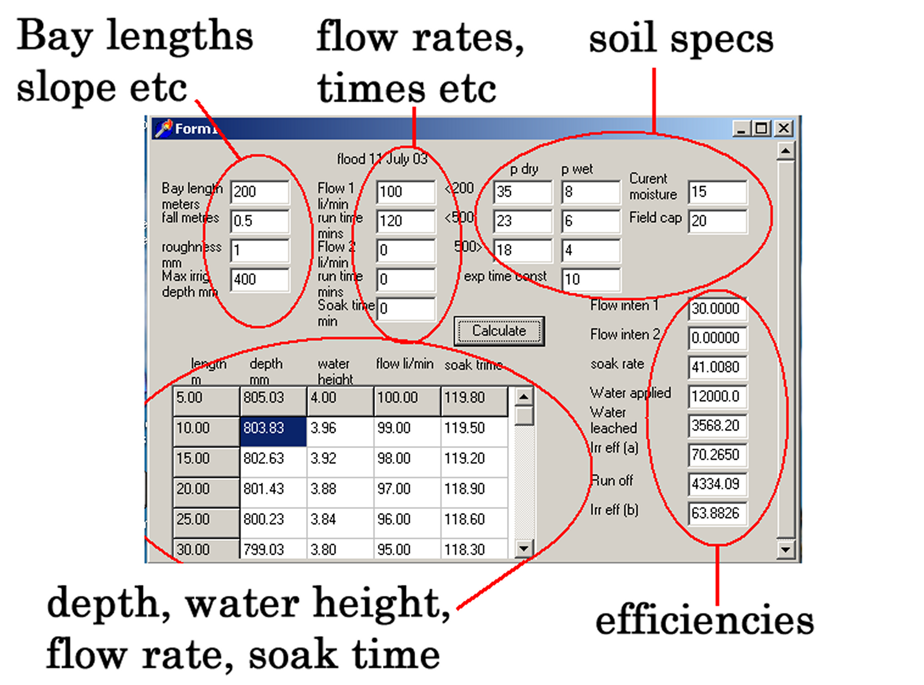

Water soaking into the ground can be calculated from the permeability of the soil. Permeability can however depend quite significantly on how much water there is in the soil, a dry clay for example is extremely permeable, it may even crack so water just runs straight through, but as water soaks into the pores the clay swells and seals. To describe this we can use two different set of data, one wet and one dry, for each of the various levels. We also need a time constant, to describe how rapidly the soil changes its permeability.

Soil characteristics have a major effect on how well flood irrigation works. Expanding clays with a large difference in permeability’s between a deep wetted layer and the shallower laminates give better water movement across the surface, in some cases they are so impervious that it may be difficult to ensure adequate water penetration. Uniform soils with higher permeability’s allow excess water to pass the root zone.

It is interesting to vary the flow rate throughout filling. The current software has three stages, in the first two the flow rate and time can be varied, the third stage is a soak period to analyze how the water sitting above the ground is redistributed after the flow into the bay has stopped.

What do we get? The water distribution or wetted profile is the key.
A summary shows how much water has been applied, how much water has been lost by soaking beyond a specified root zone depth and how much water has been lost by run off.

Analyzing results

Sample results are shown for a typical 200 metre long bay with 0.5 metres fall. The soil type is a typical expanding clay loam, with significant difference in permeability at different depths between the wet and dry states.

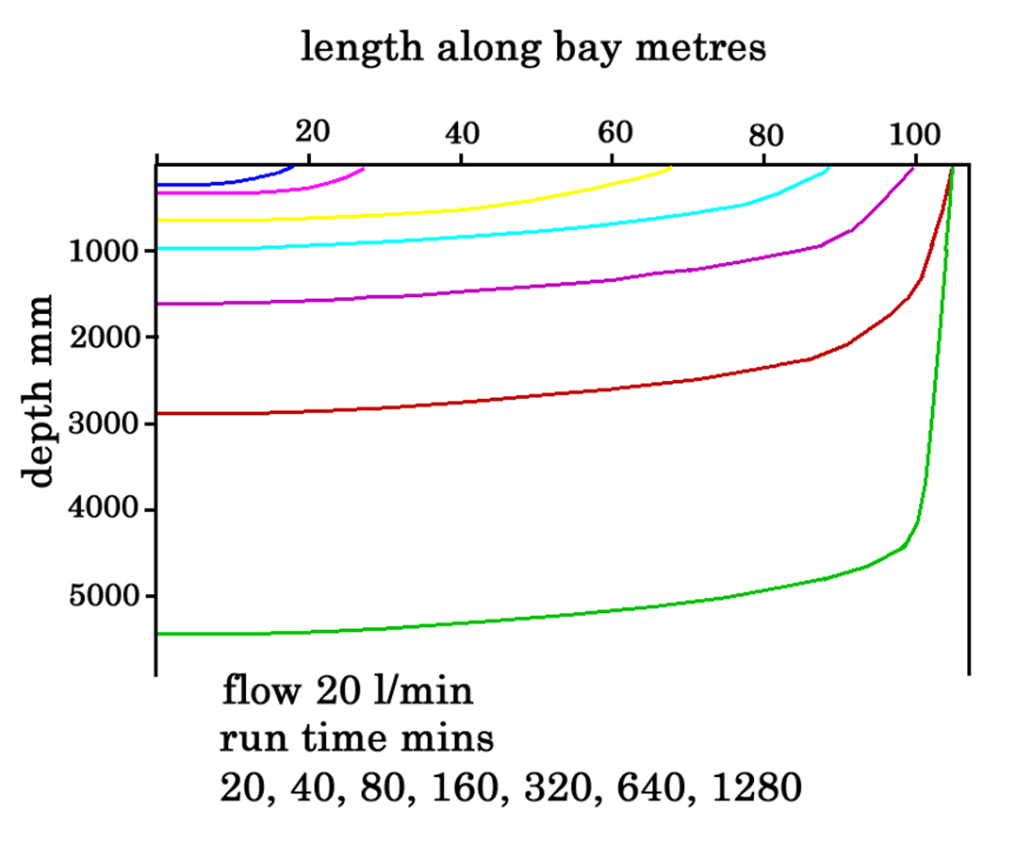 | Results showing the effect of increasing run time. At first the water moves further down the field but eventually stops when the soak rate equals the rate at which water is applied.  The maximum flow length is 105 metres regardless of how long water is applied.

We see that if we fix the flow rate and scan the run time that the water will progressively move further down the block until a maximum flow length is reached.

Length  metre | Flow rate  Litre/min/metre | Distribution  efficiency
200 | 150 | 7.2%
200 | 200 | 53%
200 | 320 | 65%
20 | 20 | 75%
20 | 40 | 95%

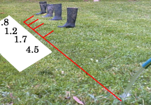 | Simple hose experiment  Numbers show how far the water has travelled every 5 minutes.  First 5 mins = 4.5 metres  Second 5 mins = 1.7 metres  Third 5 mins = 1.2 metres  Forth 5 mins = .8 metres

As the wetted area increases the rate of water loss by infiltration into the soil increases, the speed of the flow front reduces and eventually stops. After that all the water is lost to infiltration. The area around the hose is very wet deep into the ground while the edge of the wetted area is only wet on the surface.

This very simple practical test of running water over the surface and measuring flow front velocity, although crude is very informative. We can also measure how far the water has infiltrated into the ground at points along the flow path. We can then use the computer simulation to classify the soil characteristics. This gives us reliable information for later design work.

The next experiment is to look at the effect of varying flow rate, keeping the run time fixed.

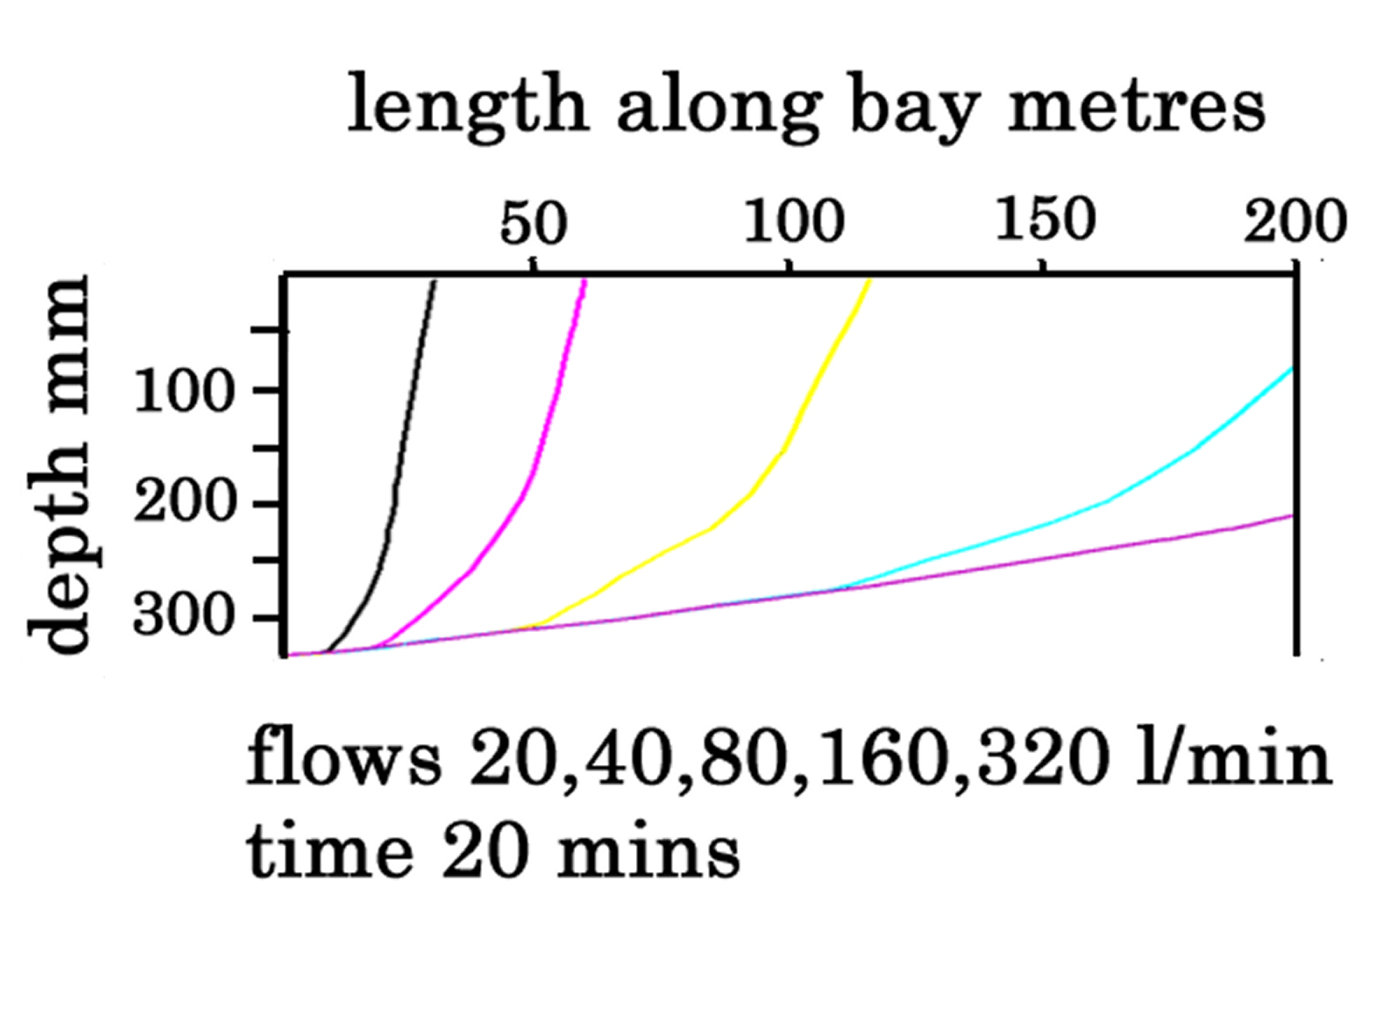 | Increasing flow rate does not affect the start but gives a better water distribution with more water at the end.  If the bay were only 20 metres long there would be a good water distribution throughout.

We see that when we keep the run time fixed that the depth at the start of the bay always remains the same regardless of flow rate. As the wetted area increases the rate of water loss by infiltration into the soil increases, the speed of the flow front reduces and may not reach the end of the bay.

If the flow rate is high enough the water will easily reach the end of the bay however for the water to properly soak into the ground the flow must be maintained after it has reached the end of the field giving significant run off.

We could immediately improve efficiency flooding the bay using a very high flow rate then dropping to a lower flow rate close to the infiltration rate (which is shown on the computer print out) to avoid run off, but get good wetting at the end of the bay.

High flow rates versus short bays

To achieve this high efficiency very high flow rates are required which means very large delivery channels coupled with sophisticated control to switch from high to low flow. The maximum flow rate shown in the graph is 320 litres per minute which gives an application rate of 96 mm per hour, which is some ten times the application rate commonly used in flood irrigation.

How practical is this? Well if we have plenty of money and can build large channels and are prepared to install proper flow control the answer is very practical. But what about poor countries? They may not have the money for large dams and channels but they also need to be harnessing the many relatively small flows, from streams, springs and aquifers which may be available locally.

However if we look closer at the simulation results we can see some very interesting numbers. At the almost absurdly high flow rate of 320 litres per minute the depth at the end of the 200 metre bay is 210 mm which is still only 65% of the depth at the start of the bay, (323 mm).

In the early sections of the bay, even at the lowest flow rate of 20 litres per minute, which is only 6.25% of the maximum flow rate, the penetration depth at the 20 metre is 251 mm which is 75% of the depth at the start of the bay. While at just 40 litres per minute, still very modest and only 12.5 of the maximum flow, the penetration depth is 323 mm which is 97% of the depth at the start of the bay.

To summarize;- reducing the length of the block gives a high efficiency with a uniform spread of water along the block, even using very low flow rates.

To reduce bay lengths while still using conventional channels would be absurd, we would simply waste more water in the channels than we would gain by efficiency on the block.

This highlights the classic dilemma in designing a flood irrigation bay, finding that compromise between losing water in channels and losing water in the bay itself. The net result is that most bays around the world are far too long to be really efficient.

Open channels are really the only practical way of delivering the high flows to flood irrigating large areas; it simply costs too much money for the massive pipes to achieve the required flow rates. However we simply don’t need these massive flow rates if we are only irrigating short bays. It therefore becomes economic to use pipes and as the pressure is very low these can be simple low cost flexible pipe or fluming.

What we need is a cheap and simple valve system to split an irrigation bay up into a number of short sections so that each section can be irrigated in turn.

This gives high efficiency even with low flows so we can take advantage of all the small water sources which cannot be effectively used by flood irrigation.

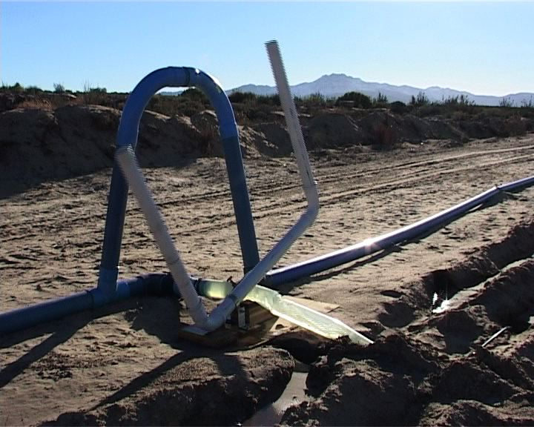 | 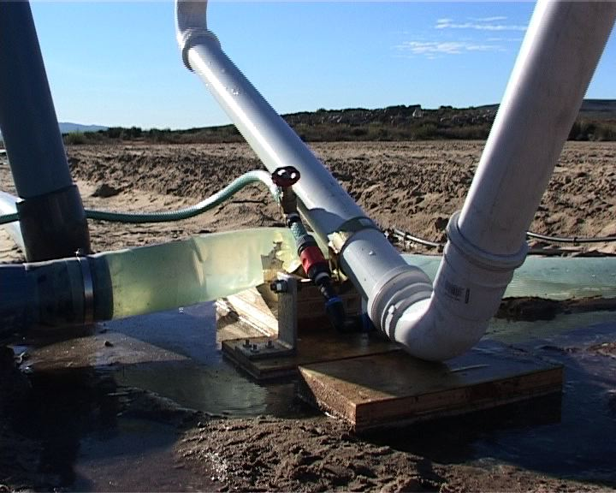

The solution is the tilt valve, a remarkably simple yet sophisticated device. Basically it is a pipe which is gradually filled with water which squeezes the flexible delivery plastics pipe shut.

However it is not quite that simple. If the pipe was simply progressively filled with water there would be a slow shut off with the flow rate gradually reducing. This is exactly the opposite of what is required. The valve should stay fully open until it is time to close and then snap shut.

This is achieved by a having two chambers, the first chamber to fill actually holds the valve open, after a period the second chamber fills sufficiently to overbalance the valve, the water from the first chamber then flows into the second chamber giving an abrupt shutting action.
The next problem is that in a large scheme there may be many valves, how do we arrange the sequence in which they open and shut?

This is achieved by a system of risers, which directs water into the first valve, when this valves shuts the water is deflects over the riser to the next valve.

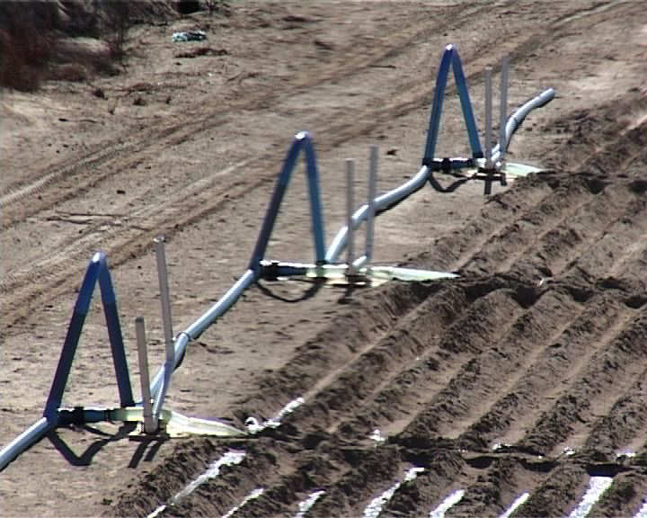 | When the tilt valve is open the riser deflects water into this micro block, when the valve shuts water flows over the riser so water is directed to the next micro block.

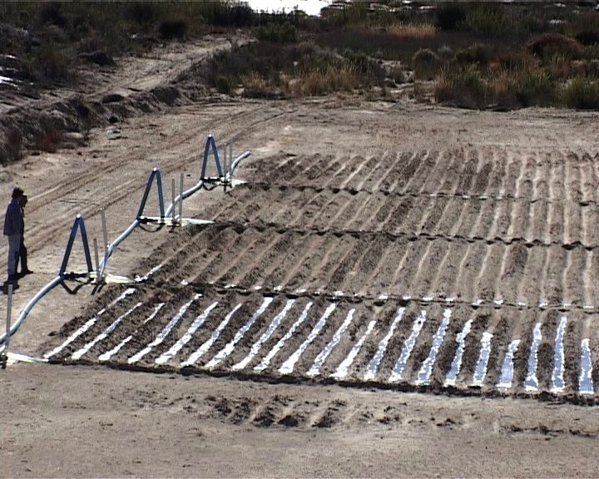 | It is more efficient to run the water down the block in small furrows as this is far more efficient hydraulically but also uses the highly efficient subsurface flow to distribute water sideways, without evaporation losses  Note this block is blown sand, impossible to irrigate with conventional flood.

.

A system of flow balancing has been developed in which a computer program calculates emitter sizes to compensate for pressure drops.

Design and installation

The first and highly critical step is to measure the characteristics of the soil. This is done in a special test in which water is flowed down a small channel or furrow and the velocities and penetration depth measured.

Different soils will lead to totally different designs. Virtually any soil can be irrigated with the Micro Flood technology but the final designs may be totally different. A sandy porous soil will require short run lengths and irrigation times and preferably high flow rates, while a soil with a lower layer of expanding clay will allow much longer run lengths and lower flows.

The computer simulation is then used to determine the size of the micro blocks, considering the soil characteristics in conjunction with the available flow rate. High flows allow large blocks to be used while sandy soils require smaller blocks.

Next further software is used to design the hydraulics of the system establishing pipe and emitter sizes, flow rate and required heads.

Scheduling

Any irrigation system, however good its potential is, is only as good as its management, so scheduling is essential to ensure efficient use of water.

Affluent farmers can afford the latest soil moisture monitoring equipments to help them schedule correctly but what about the many farmers who cannot afford such luxuries? Another way had to be found. The easiest way of measuring soil moisture is to apply a known amount of water then see how far the water soaks into the ground. This can be done using simple hand tools like an auger or even a spade.

Traditional flood irrigation usually applies large volumes of water, about 50 mm, which are only applied every 5 to 10 days. Plants grow much better if they have smaller but more regular watering. Micro Flood applies these smaller but more regular irrigations, to give higher productivity. Systems are generally designed to apply a fixed amount of water, say 5 mm at each irrigation depending on the water holding capacity of the soil.

The still leaves the farmer with the job of deciding when to irrigate.

Evaporation meter

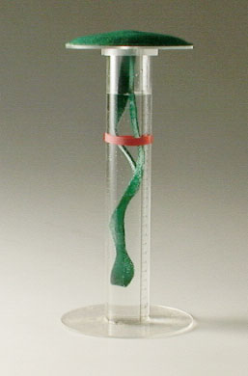 | A simple evaporation meter which works just like a plant has been developed. The water stored in the tube represents the water in the soil, the wick representing the trunk or stalk and the top represents the leaves.  This can be used just like a conventional evaporation pan but can also be fitted under one of the flood-emitters so it is filled at every irrigation.

A rubber band can be placed around the tube to act as a marker. When the water level drops to the marker it is time to re-irrigate. This gives a constant evaporation between irrigations. The irrigation depth is checked after irrigation by digging a hole or using an auger and the position of the band adjusted to change the evaporation between irrigations.

Flood irrigation and bad PR

Flood is still by far the largest user of water using some 95% of all irrigation water around the world, because it is simple and cheap but is widely thought of as grossly inefficient. The reality is that most flood irrigation systems are inefficient. This inefficiency is not an intrinsic feature of flood; it is just the way it has been implemented.

Micro Flood can be more effective than the much more expensive alternatives. Sprinklers wet the entire surface area so there are significant evaporation losses, some during application and the rest by evaporation from the upper layers of the soil.

By contrast furrows results in much of the water going straight to the useful zone by subsurface flow.

Drip can apply very small quantities of water; however the water distribution is generally very poor with little patches of wet soil.

The key issue is how much growth we get from a given amount of water.
Micro Flood has the natural breathing action of Flood and drain systems, one of the most productive systems of irrigation, widely used in hydroponics It provides a natural breathing action, replacing stale air containing carbon dioxide and ethylene, which act as growth inhibitors, with fresh oxygen.

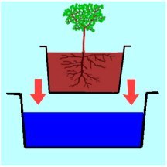 | 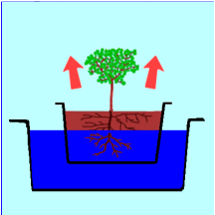 | 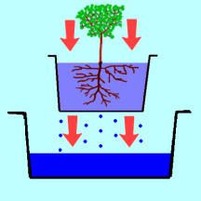
A plant in a pot is immersed in water, often containing nutrients | The water soaks into the soil expelling all the stale air. | As the water drains it sucks fresh air in behind giving ideal growing conditions.

Conclusions

So what does all this mean? It means that the worlds malnourished have a highly efficient irrigation system which is still low cost and gravity fed.

It means that high flow rates, associated with conventional flood irrigation are no longer required.

It means that many water sources, which were too small for effective flood irrigation can now be used and the traditional large open channels can be replaced with small diameter low cost pipes, saving significant quantities of water.

It means that any soil, even sandy highly permeable sandy soils can be irrigated.

It means increasing food production by some 40%.

In simple terms this means we can feed more people from our finite water resources.

It can be truly said that this is the most significant advance in flood irrigation since the Sumerians 6,000 years ago.

